SQL & Microsoft Power Bi Tools

**ACERTIFICATECOURSECONDUCTED**

**BY**



## THESURETRUST

**SkillUpgradationforRural-youthEmpowerment –TRUST(**[**www.suretrustforruralyouth.com**](http://www.suretrustforruralyouth.com/)**)**

**COURSETRAININGATTENDEDBY**

**Dubbaka Srikanth**

### December 2022- March2023



Declaration

This is to certify that Mr. Dubbaka Srikanth has successfully completed the fourmonths training in “SQL & Microsoft Power Bi Tools” courseconductedbySURETrust duringtheperiodDecember2022-March2023.

By

Mr.Uma Mahesh

SeniorManageratNovac Tech  
TrainerinSURETrust

Prof.Radhakumari Mrs.

VandanaNagesh

ExecutiveDirector&Founder Director &Founder

SURE Trust SURETrust

**TABLEOFCONTENTS**

1. TheSURETRUST
2. CourseContent
3. ConductoftheCourse:
   * Studentbyelaws
   * WrittenTests
   * Assignments
4. StudentFeedback:
5. UniquenessoftheCourseaccordingtostudent:
6. ConcludingRemarks:
7. **IntroductiontotheSURETRUST**

IntroductiontoTheSURETRUST:

The SURE TRUST is born to enhance the employability of educated unemployed rural youth.It is observed that there is a wide gap between the skills acquired by students from theacademic institutions and the skills required by the industry to employ them. Employabilityenhancementisdonethroughgivingoneononetraininginemergingtechnologies,completelythroughonlinemode.ThemissionoftheSURETRUSTistobridgethegapbetweentheskillsacquiredandtheskillsrequiredbytrainingtheminthemostemergingtechnologiessuch as Artificial Intelligence (AI), Python Program, Machine Learning (ML), Deep Learning(DL), Data Science & Data Analytics, Blockchain Technology, Robotic Process Automation(RPA), Project Management, Excel for Business Application, Statistical tools & Applications,SpokenEnglishandBusinessCommunicationetc.,thatwillenhancetheiremployability.Aftercompletion of four months training in the course, the trainees will get live projects fromindustries as internship activity to get experience in applying to real time situation what theyhave learnt during the course. These projects will give them hands on experience which ismuch sought after by the prospective industry employing them. Currently students from alloverIndiaareenrollingforvariouscoursesofferedbytheSURETRUST.TheSURETRUSToffers every course free of cost with no financial burden of any kind to students. This initiative ispurelyaservice-orientedoneaimingtoguidetheruralyouthwhoareeducatedbutunemployed due to lack of upgradation in their skill sets. The birth of SURE TRUST is a Godgivenboontoruralyouthwhocouldreachgreatheightseitherinemploymentorinentrepreneurshiponcetheyreceivethetrainingofferedfollowedbythecompanyinternship.Many companies are coming forward tojoin their hands with us by offering internshipprojects tohandholdandleadtheruralyouthintheircareersettlement.

VisionoftheSURETRUST:

ThevisionoftheSURETRUSTistoenhancetheemployabilityofeducatedunemployedyouth,particularlyliving inruralareas,throughskillupgradation,withnocosttothestudents.

MissionoftheSURETRUST:

The mission is to bridge the gap between the skills acquired in the academic institutions andtheskillsrequiredinindustries asapre-conditionforemployment.

FunctioningoftheSURETRUST:

Therearethreededicated,committed,andhard-workingwomenontheboardofmanagement of the SURE TRUST who will look into the various administrative and othermatters relating to the enrolment of students, organizing trainers, entering into agreementswithcompaniesforgettingliveprojectstostudentsasinternshipprograms,andsoon.AllthethreewomenontheboardareallthealumnifromSriSathyaSaiInstituteofHigherLearning,Anantapur Campus, deemed to be a University. The women board is supported by fiveeminent advisories who are from different walks of life and have made outstanding mark incareer in their respective fields. For more details about SURE TRUST please visit the website[www.suretrustforruralyouth.com](http://www.suretrustforruralyouth.com/)

1. CourseContent:

The SURE TRUST conducts a four months training for every course on a uniform basis. Asessionspanningacrossonetoone&halfhouristakenbythetrainersforeverymajorcourse.Sessions are conducted to complete the predesigned course structure within the fixed timeperiod. Course content is designed to suit the current requirement of the Industry andvalidated by the industry experts. The course content of all these courses is so dynamic thatany changed condition noticed in the industry will automatically get reflected in the contentoftherespectivecourse.Asthecoursecontentisdynamic,theFollowingisthecoursecontentofthecurrentcourse in Sql and Power BI tools:

**SQL Topics:**

➢ Introduction to sql server

➢ Data types

➢ Installation of sql - serer

➢ Commands

➢ Constraints

➢ Joins

➢ Identity Property

➢ Set Operators

➢ String Functions

➢ Date Functions

➢ Ranking Function

➢ Aggregate Functions

➢ CTE (Common Table Expression)

➢ Case statements

➢ Control statements

➢ Sub Queries

➢ Temporary Table & Table Variable

**T-SQL Topics:**

➢ Views

➢ Indexes

➢ Synonyms

➢ Triggers

➢ User Defined Functions

➢ Stored Procedures

➢ Sub queries

➢ Complex queries

➢ Query Tuning Techniques

➢ Transactions

➢ Complex queries

➢ Isolation Levels

➢ Import & Export

**SSIS (SQL Server Integration Services):**

Tasks:

➢ Dataflow Task

➢ Execute SQL Task

➢ Bulk insert Task

➢ Execute Process Task

➢ Execute Package Task

➢ File System Task

➢ FTP Task

➢ Send Mail Task

**Containers:**

➢ For Loop Container

➢ For Each Loop Container

➢ Sequence Container

**Sources:**

➢ Excel Source

➢ Flat File Source

➢ OLEDB Source

Transformations:

➢ Derived Column

➢ Data Conversion

➢ Aggregate

➢ Conditional Split

➢ Merge

➢ Merge Join

➢ Union ALL

➢ Look Up, Fuzzy Lookup & Fuzzy Group

➢ SCD (Slowly Changing Dimension

➢ Multi Cast

➢ Row Count

➢ Sort

**Destinations:**

➢ Excel Destination

➢ Flat File Destination

➢ OLEDB Destination

➢ XML Destination

**SSIS Concepts:**

➢ Parameters

➢ Variables

➢ Event Handlers

➢ Package Explorer

➢ Loggings

➢ Package Configurations

➢ Parallelism

➢ Package & Project Deployment

**SSRS (SQL Server Reporting Services)**

Reports:

➢ Data Sources, Data Set (Embedded & Shared)

➢ Table Report, Matrix Report, Sub Report

➢ Drill Down Report, Drill Through Report

➢ Parameterized Report, Cascading Report

➢ Linked Report

SSRS Concepts:

➢ Report Deployment

➢ Report Server

➢ Report Manager

➢ SSRS Expressions

➢ SSRS Groupings

**MicroSoft Power BI**

Power BI Complete Introduction

➢ Power BI Introduction

➢ Data Visualization, Reporting

➢ Business Intelligence(BI), Traditional BI, Self-Serviced BI

➢ Cloud Based BI, On Premise BI

➢ Power BI Products

➢ Power BI Desktop (Power Query, Power Pivot, Power View)

➢ Flow of Work in Power BI Desktop

➢ Power BI Report Server, Power BI Service, Power BI Mobile

➢ Flow of Work in Power BI / Power BI Architecture

➢ A Brief History of Power BI

**PBI Desktop Installation, PBI Desktop & Service Overview**

➢ Power BI Desktop Installation

➢ Building Blocks of Power BI

➢ Datasets, Visualizations, Reports, Dashboards, Tiles

➢ Power BI Desktop User Interface

➢ Fields Pane, Visualizations pane, Ribbon, Views, Pages Tab, Canvas

➢ Overview of Power Query / Query Editor - Extract, Transform & Load Data

➢ Connecting to Data Sources, Establish connection to the Excel source

➢ Importing Data into Power BI or Query Editor

➢ Transforming the Data using Power Query

➢ Model the Data using Power Pivot – Relationship View

➢ Creating New Measures and New Columns using DAX – Data View

➢ Visualizing the Data using Power View and Power Maps – Report View

➢ Saving and Publishing the Visuals or Reports

➢ Logon to Power BI Service

➢ View the Reports in PBI Service and Share the reports

**Power Query**

Introduction to Power Query – Extract, Transform & Load

➢ Data Transformation, Benefits of Data Transformation

➢ Shape or Transform Data using Power Query

➢ Overview of Power Query / Query Editor, Query Editor User Interface

➢ The Ribbon (Home, Transform, Add Column, View Tabs)

➢ The Queries Pane, The Data View / Results Pane, The Query Settings Pane,

Formula Bar

➢ Advanced Editor – Complete ETL Code

➢ Saving Your Work – Appling ETL Changes – Loading into Power Pivot Model

➢ Power Query Conceptually

**Datatypes and Filters in Power Query**

➢ Datatypes, Changing the Datatype of a Column

➢ Filters in Power Query

➢ Auto Filter / Basic Filtering

➢ Filter a Column using Text Filters

➢ Filter a Column using Number Filters

➢ Filter a Column using Date Filters

➢ Filter Multiple Columns

Inbuilt Column Transformations

➢ Remove Columns / Remove Other Columns

➢ Name / Rename a Column

➢ Reorder Columns or Sort Columns

➢ Add Column / Custom Column

➢ Split Columns

➢ Merge Columns

➢ PIVOT, UNPIVOT Columns

➢ Transpose Columns

**In built Row Transformations**

➢ Header Row or Use First Row as Headers

➢ Keep Top Rows, Keep Bottom Rows

➢ Keep Range of Rows

➢ Keep Duplicates, Keep Errors

➢ Remove Top Rows, Remove Bottom Rows, Remove Alternative Rows

➢ Remove Duplicates, Remove Blank Rows, Remove Errors

➢ Group Rows / Group By

Combine Queries (Append Queries & Merge Queries)

Append Queries / Union Queries

➢ Append Queries

➢ Append Queries as New

➢ Append 2 or more files individually with different queries

➢ Appending multiple files of same type from a folder using single query

➢ Query Options

➢ Copy Query, Paste Query

➢ Delete Query, Rename Query

➢ Enable Load, Include in report Refresh

➢ Duplicate Query, Reference Query

➢ Move to Group, Move Up, Move Down

**Merge Queries / Join Queries**

➢ Merge Queries, Merge Queries as New

➢ Default Types of Joins / Join Kinds / Merge Type

➢ Left Outer (all from first, matching from second)

➢ Right Outer (all from second, matching from first)

➢ Full Outer (all rows from both)

➢ Inner (only matching rows)

➢ Left Anti (rows only in first)

➢ Right Anti (rows only in second)

➢ Cartesian Join or Cross Join

**Power Pivot**

Power BI Data Modeling – Relationship View

➢ Data Modeling Introduction

➢ Relationship, Need of Relationship

➢ Relationship Types / Cardinality in General

➢ One-to-One, One-to-Many (or Many-to-One), Many-to-Many

➢ AutoDetect the relationship, Create a new relationship, Edit existing relationships

➢ Make Relationship Active or Inactive

➢ Delete a relationship

➢ Cross filter direction (Single, Both), Assume Referential Integrity

**Enhancing the Data Model - DAX**

➢ What is DAX, Calculated Column, Measures

➢ DAX Table and Column Name Syntax

➢ Creating Calculated Columns, Creating Measures

➢ Implicit Vs Explicit Measures

➢ Calculated Columns Vs Measures

➢ DAX Syntax & Operators

➢ DAX Operators

➢ Types of Operators

➢ Arithmetic Operators, Comparison Operators, Text Concatenation Operator, Logical

Operators

**DAX Functions Categories**

➢ Date and Time Functions

➢ Logical Functions

➢ Text Functions

➢ Math & Statistical Functions

➢ Filter Functions

➢ Time Intelligence Functions

**DAX Date & Time Functions**

➢ YEAR, MONTH, DAY

➢ WEEKDAY, WEEKNUM

➢ FORMAT (Text Function) Month Name, Weekday Name

➢ DATE, TODAY, NOW

➢ HOUR, MINUTE, SECOND, TIME

➢ DATEDIFF, CALENDAR

➢ Creating Date Dimension Table

**DAX Text Functions**

➢ LEN, CONCATENATE (&)

➢ LEFT, RIGHT, MID

➢ UPPER, LOWER

➢ TRIM, SUBSTITUTE, BLANK

**DAX Logical Functions**

➢ IF

➢ TRUE, FALSE

➢ NOT, OR, IN, AND

➢ IFERROR

➢ SWITCH

**DAX Math and Statistical Functions**

➢ INT

➢ ROUND, ROUNDUP, ROUNDDOWN

➢ DIVIDE

➢ EVEN, ODD

➢ POWER, SIGN

➢ SQRT, FACT

➢ SUM, SUMX

➢ MIN, MINX

➢ MAX, MAXX

➢ COUNT, COUNTX

➢ AVERAGE, AVERAGEX

➢ COUNTROWS, COUNTBLANK

**DAX Filter Functions**

➢ CALCULATE

➢ ALL

➢ RELATED

**DAX Time Intelligence Functions**

➢ Time Intelligence Introduction

➢ TOTALMTD, TOTALQTD, TOTALYTD

➢ PREVIOUSDAY, PREVIOUSMONTH, PREVIOUSQUARTER, PREVIOUSYEAR

➢ NEXTDAY, NEXTMONTH, NEXTQUARTER, NEXTYEAR

➢ SAMEPERIODLASTYEAR

➢ YOY Growth

➢ MOM Growth

**Power View**

Report View / Power View

➢ Report View User Interface

➢ Fields Pane, Visualizations pane, Ribbon, Views, Pages Tab, Canvas

➢ Visual Interactions

➢ Interaction Type (Filter, Highlight, None)

➢ Visual Interactions Default Behavior, Changing the Interaction

**Filters in Power View**

➢ Filter Types

➢ Visual Level Filters, Page Level Filters, Report Level Filters, Drill Through Filters

➢ Filter Sub Types

➢ Basic Filtering, Advanced Filtering, Top N, Relative Date Filtering

➢ Numeric field filters, Text field filters, Date and Time field Filters

**Grouping, Binning & Sorting**

➢ Grouping and Binning Introduction

➢ Using grouping, Creating Groups on Text Columns

➢ Using binning, Creating Bins on Number Column and Date Columns

➢ Sorting Data in Visuals

➢ Changing the Sort Column, Changing the Sort Order

➢ Sort using column that is not used in the Visualization

➢ Sort using the Sort by Column button

Hierarchies and Drill-Down Reports

➢ Hierarchy Introduction, Default Date Hierarchy

➢ Creating Hierarchy, Creating Custom Date Hierarchy

➢ Change Hierarchy Levels

➢ Drill-Up and Drill-Down Reports

➢ Data Actions, Drill Down, Drill Up, Show Next Level, Expand Next Level

➢ Drilling filters other visuals option

**Power BI Visualizations**

➢ Visualizing Data, Why Visualizations

➢ Visualization types, Field Wells

➢ Visuals for Filtering, Visualizing Categorical Data, Visualizing Trend Data

➢ Visualizing KPI Data, Visualizing Tabular Data, Visualizing Geographical Data

➢ Leveraging Power BI Custom Visuals

**Visuals for Filtering**

➢ Slicer Visualization

➢ When to use a Slicer

➢ Create and format Slicer Visualization

➢ Hierarchy Slicer (Custom Visualization)

➢ When to use a Hierarchy Slicer

➢ Create and format Hierarchy Slicer

➢ Advantages of Hierarchy Slicer

**Visualizing Categorical Data**

➢ Create and Format Bar and Column Charts

➢ Create and Format Stacked Bar Chart Stacked Column Chart

➢ Create and Format Clustered Bar Chart, Clustered Column Chart

➢ Create and Format 100% Stacked Bar Chart, 100% Stacked Column Chart

➢ Create and Format Pie and Donut Charts

➢ Create and Format the Tree Map Visual

➢ Create and Format Scatter Charts

**Visualizing Trend Data**

➢ Line and Area Charts

➢ Create and Format Line Chart, Area Chart, Stacked Area Chart

➢ Combo Charts

➢ Create and Format Line and Stacked Column Chart, Line and Clustered Column Chart

➢ Create and Format Ribbon Chart, Waterfall Chart, Funnel Chart

Visualizing KPI Data

➢ Create and Format Gauge Visual, KPI Visual

➢ Create and Format Card Visualization, Multi Row Card

Visualizing Tabular Data, Geographical Data & R Script Visual

➢ Create and Format Table Visual, Matrix Visualization

➢ Create and Format Map Visual, Filled Map Visual, Arc GIS Maps Visual

➢ Create and Format R Script Visual

**Power BI Service**

Power BI Service Introduction

➢ Power BI Service Introduction, Power BI Cloud Architecture

➢ Creating Power BI Service Account, SIGN IN to Power BI Service Account

➢ Publishing Reports to the Power BI service, Import / Getting the Report to PBI Service

➢ My Workspace / App Workspaces Tabs

➢ DATASETS, WORKBOOKS, REPORTS, DASHBOARDS

➢ Working with Datasets, Creating Reports in Cloud using Published Datasets

➢ Power BI Datasets Live Connection using Desktop

➢ Working with Workbooks, working with Reports, Sharing Reports

Dashboards Development

➢ Creating Dashboards

➢ Pin Visuals and Pin LIVE Report Pages to Dashboard

➢ Advantages of Dashboards

➢ Interacting with Dashboards

➢ Adding Tiles to Dashboards

➢ Web Content, Image, Text Box, Video

➢ Formatting Dashboard

➢ Sharing Dashboard

**Data Gateways**

➢ Introduction to Data Gateways

➢ How Data Gateways work

➢ Connect to an on premise Data Source by using a Data Gateway

➢ Download Data Gateway

➢ Installing a Data Gateway

➢ Types of Gateways

➢ On-premises Data Gateway, On-premises Data Gateway (personal mode)

➢ Manage Data Gateway

➢ Add and Remove Administrators

➢ Add Data Source, Add or Remove Users to a Data Source

➢ Refresh On Premise Data

➢ Configuring Automatic Refresh using Schedules

**Sharing Power BI Content using Apps and Content Packs**

➢ Introduction to App

➢ Publish an App

➢ Update a Published App

➢ Manage Content in App

➢ Include in App, Exclude in App

➢ Sharing App

➢ Entire Organization, Specific individuals or group

➢ Un publishing an App

➢ Content Pack Introduction

➢ Create Content Pack

➢ Sharing Content Packs

➢ Specific Groups, My Entire Organization

➢ Selecting the Content / Items to Publish or Share

Row Level Security in Power BI

➢ Introduction to Row Level Security

➢ Row Level Security (RLS) with DAX

➢ Manage Roles, Creating Roles, Testing Roles

➢ Adding Members to Roles in Power BI Service

➢ Dynamic Row Level Security

➢ Creating Users Table and Adding to the Model

➢ Capturing users using UserName () or UserPrincipalName () DAX Functions

**ADD ON**

➢ Real-time Project Explanation

➢ Resume Preparation

➢ Interview Questions Discussions

➢ Mock Interviews

**************************

3.**Conductofthecourse:**

1. Modalities for the conduct of all the courses are fixed by the SURE TRUST which are uuniformlyfollowedacrossthecourses.
   * Modeof Training ---Online
   * PeriodofTraining ---Fourmonths
   * Sessionsper week --- 3to6
   * Lengthof thesession --- 1to2hours
   * Teststobetaken --- 2permonth
   * Assignments --- 2permonth
   * Last15days --- Final practiceandpreparingthecoursereport
2. **Studentbyelaws:**

StudentsenrollingforthecoursesunderSURETRUSTarestrictlyrequiredtofollowthefollowingbyelawssetforthem:

Byelawsforstudents tobecomeeligibleforcertificateatthe end ofthecourse:I.**MinimumAttendance:**

Everystudentmustput inaminimumof85%attendanceinattendingtheclasses forgettingtheeligibilitytoreceivethecertificates.

II**..Twowrittentestsaretobetakenineachmonth:**

Sincetheobjectiveofthecertificationprogramistoturnoutwellqualifiedstudentsfromtherespectivecourses, minimum two written tests are to be taken in each month for each course to ensure that thestudentsarepulledalongthe expectedlineofstandard.

1. **Assignmentsubmissions:**

Tenexercisesconstitutingoneassignmentforeverytwotothreenewfunctions/topicstaught,resultinginminimumsevensuchassignmentsaretobesubmittedduringthefourmonthsperiod.

1. **Preparingthefinalcoursereportintheprescribedformat:**

During the last fifteen days in the fourth month, students many be asked to consolidate and compile all theassignments submitted in a word document along with the other chapters which will constitute a course reportfor each student. This report will be the unique contribution a student carries from the trust to show case therigoroustraininghe/shereceivedduringthefourmonthsperiod.Besidesthereportwillstandasatestimonyforthedetailedlearningastudent hasacquiredinthechosenarea.This willfacilitatetheindustryinhandpickingtherequiredstudentforthejob.

1. **ExternalViva-voce:**

Every student has to successfully clear the external viva-voce arranged in their respective course.VI.KYCnorms:

Eachstudentwishingtoenrollforthecoursemustsubmit awrittenlettersayingthathe/shewillnotdrop fromthecourseuntilitscompletion,whichwillalsobesignedbyfather/ motherbesidesthestudenthimself/herself.

1. **Attendthefullclass:**

All the students are expected to attend each class for full duration. Some students are observed moving out ofclasses afterlogginginwhichdoesnotgowellwiththe learningobjective of students.

1. **Ensurediscipline inthegroup:**

Allthestudentsareadvisedstrictlytofollowgroupetiquetteandrestrainfrompostinginthegroupany unethicalmessages or teasing messages or personal interactive messages. This group is purely created for academicpurposeandhence onlyacademic interactionsshouldgoon

**Power BI & SQL:**

The course is taught to the students as per the syllabus prescribed and as per the course modalities keeping inmind the bylaws set for them. Periodical tests are conducted to assess the understanding of the students in thecourse. Assignments are given to ensure that students gain versality in the solidity program and developmentof smart contracts. The assignments of the student are given below. These assignments which are done withhigh creativity and out of box thinking not only reflect the student’s innovativeness but also constitute solvedexercises in solidity for the fresh learners to practice and gain confidence. The assignments are listed below intheorderoftheirconductingduringthecourse:

**POWERBI**

**Introduction:**  
Power BI is a Data Visualization and Business Intelligence tool that converts data from different data sources to interactive dashboards and BI reports. Power BI suite provides multiple software, connector, and services - Power BI desktop, Power BI service based on Saas, and mobile Power BI apps available for different platforms. These set of services are used by business users to consume data and build BI reports.

Power BI desktop app is used to create reports, while Power BI Services (Software as a Service - SaaS) is used to publish the reports, and Power BI mobile app is used to view the reports and dashboards.

**Power BI - Architecture:**

Power BI includes the following components −

Power BI Desktop − This is used to create reports and data visualizations on the dataset.

Power BI Gateway − You can use Power BI on-premises gateway to keep your data fresh by connecting to your on-premises data sources without the need to move the data. It allows you to query large datasets and benefit from the existing investments.

Power BI Mobile Apps − Using Power BI mobile apps, you can stay connected to their data from anywhere. Power BI apps are available for Windows, iOS, and Android platform.

Power BI Service − This is a cloud service and is used to publish Power BI reports and data visualizations.

**Supported Data Sources:**

Power BI supports large range of data sources. You can click Get data and it shows you all the available data connections. It allows you to connect to different flat files, SQL database, and Azure cloud or even web platforms such as Facebook, Google Analytics, and Salesforce objects. It also includes ODBC connection to connect to other ODBC data sources, which are not listed.

**Following are the available data sources in Power BI −**

Flat Files

SQL Database

OData Feed

Blank Query

Azure Cloud platform

Online Services

Blank Query

**Other data sources such as Hadoop, Exchange, or Active Directory**

To get data in Power BI desktop, you need to click the Get data option in the main screen. It shows you the most common data sources first. Then, click the More option to see a full list of available data sources.

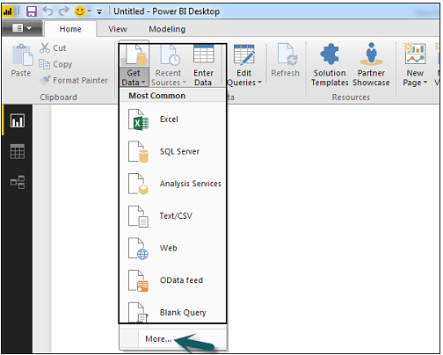

**Available Data Sources**

When you click “More..” tab as shown in the above screenshot, you can see a new navigation window, where on the left side it shows a category of all available data sources. You also have an option to perform a search at the top.

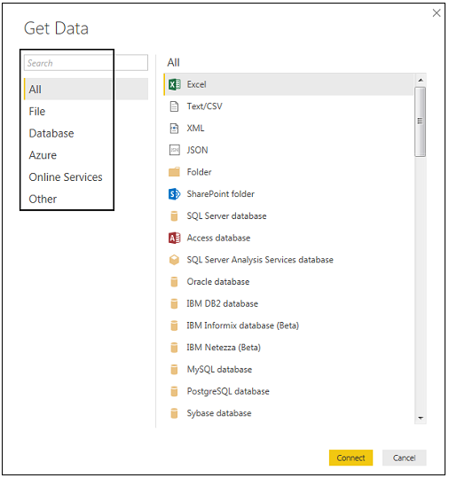

**Following are the various data sources listed −**

All

Under this category, you can see all the available data sources under Power BI desktop.

File

When you click File, it shows you all flat file types supported in Power BI desktop. To connect to any file type, select the file type from the list and click Connect. You have to provide the location of the file.

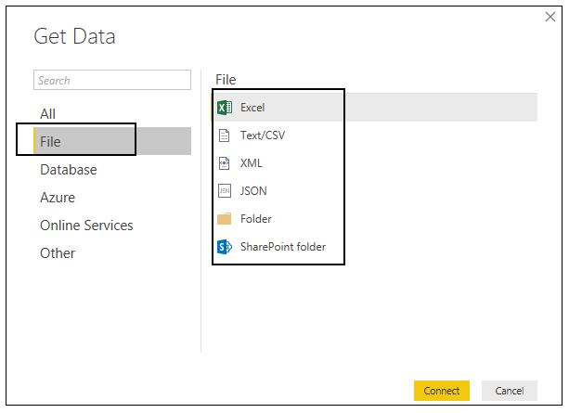

When you click the Database option, it shows a list of all the database connections that you can connect to.

Database

To connect to any database, select a Database type from the list as shown in the above screenshot. Click Connect.

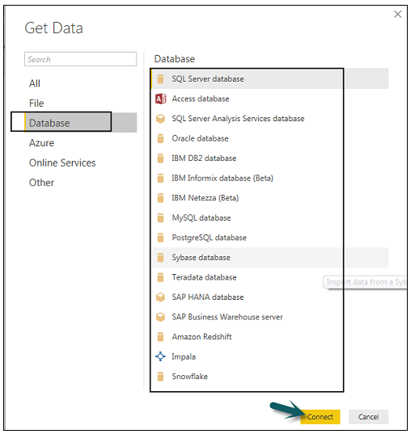

You have to pass Server name/ User name and password to connect. You can also connect via a direct SQL query using Advance options. You can also select Connectivity mode- Import or DirectQuery.

Note − You can’t combine import and DirectQuery mode in a single report.

Import vs DirectQuery

DirectQuery option limits the option of data manipulation and the data stays in SQL database. DirectQuery is live and there is no need to schedule refresh as in the Import method.

Import method allows to perform data transformation and manipulation. When you publish the data to PBI service, limit is 1GB. It consumes and pushes data into Power BI Azure backend and data can be refreshed up to 8 times a day and a schedule can be set up for data refresh.

Import Method

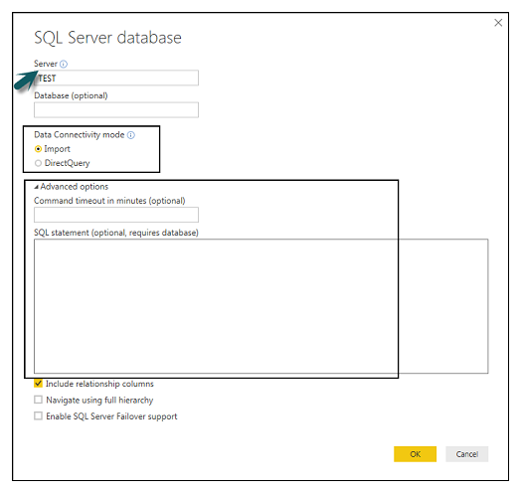

**Advantages of Using DirectQuery**

Using DirectQuery, you can build data visualizations on large datasets, which is not feasible to import in Power BI desktop.

DirectQuery doesn’t apply any 1GB data set limit.

With the use of DirectQuery, the report always shows current data.

**Limitations of Using DirectQuery**

There is a limitation of 1 million row for returning data while using DirectQuery. You can perform aggregation of more number of rows, however, the result rows should be less than 1 million to return the dataset.

In DirectQuery, all tables should come from a single database.

When a complex query is used in the Query editor, it throws an error. To run a query, you need to remove the error from the query.

In DirectQuery, you can use Relationship filtering only in one direction.

It doesn’t support special treatment for time-related data in tables.

Azure

Using the Azure option, you can connect to the database in Azure cloud. Following screenshot shows the various options available under Azure category.

Azure

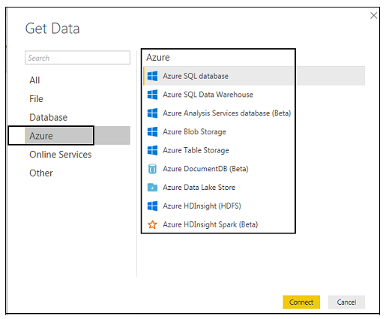

**Online Services**

Power BI also allows you to connect to different online services such as Exchange, Salesforce, Google Analytics, and Facebook.

Following screenshots shown the various options available under Online Services.

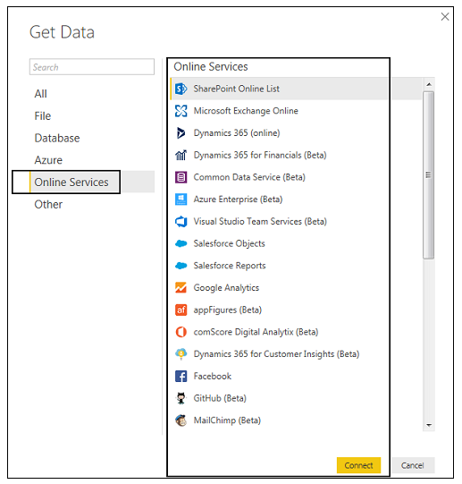

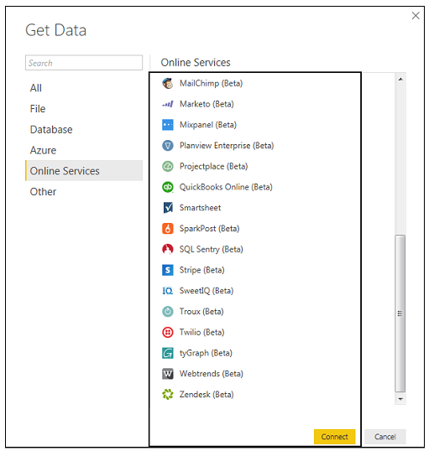

**Other**

Following screenshot shows the various options available under other category.

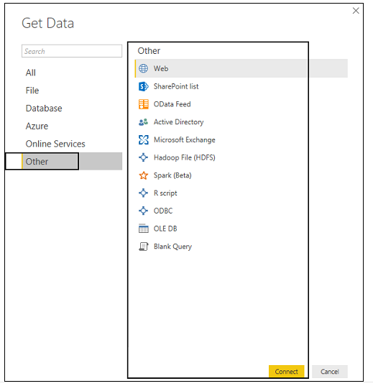

**UsingDataModelingandNavigation**

DataModelingisoneofthefeaturesusedtoconnectmultipledatasourcesinBItoolusingarelationship. Arelationshipdefineshowdatasourcesareconnectedwitheachotherandyoucancreateinterestingdatavisualizationsonmultipledatasources.

Withthemodelingfeature, youcanbuildcustomcalculationsontheexistingtablesandthesecolumnscanbedirectlypresentedintoPowerBIvisualizations. Thisallowsbusinessestodefinenewmetricsandtoperformcustomcalculationsforthosemetrics.

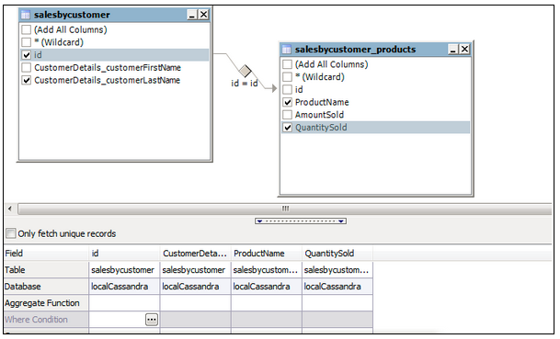

**ModelingFeature**

Intheaboveimage, youcanseeacommondatamodel, whichshowsarelationshipbetweentwotables. Bothtablesarejoinedusingacolumnname“Id”.

Similarly, inPowerBI, yousettherelationshipbetweentwoobjects. Tosettherelationship, youhavetodragalinebetweenthecommoncolumns. Youcanalsoviewthe“Relationship”inadatamodelinPowerBI.

TocreatedatamodelinPowerBI, youneedtoaddalldatasourcesinPowerBInewreportoption. Toaddadatasource, gototheGetdataoption. Then, selectthedatasourceyouwanttoconnectandclicktheConnectbutton.

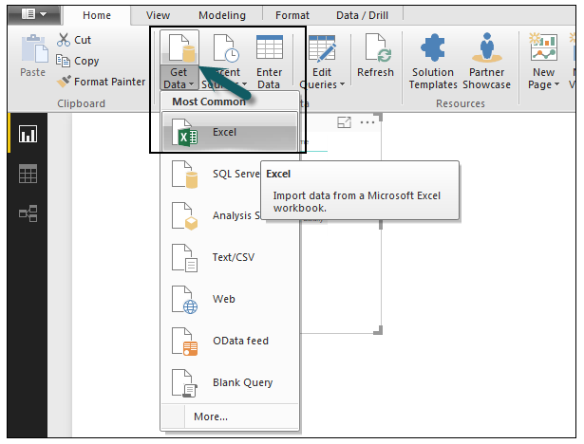

DataModelinPowerBI

Onceyouaddadatasource, itispresentedontherightsidebar. Inthefollowingimage, wehaveused2xlsfiletoimportdata - CustomerandProduct.

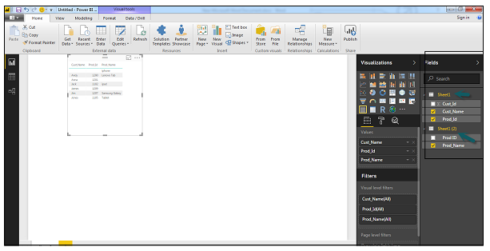

AddDataSource

InPowerBIontheleftsideofthescreen, youhavethefollowingthreetabs −

Report

Data

Relationships

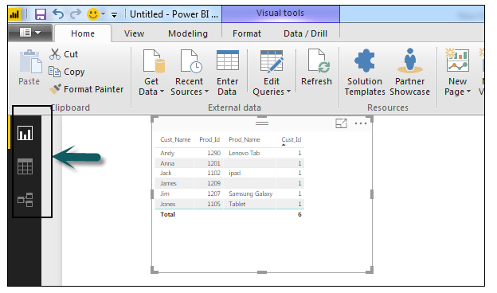

WhenyounavigatetotheReporttab, youcanseeadashboardandachartselectedfordatavisualization. Youcanselectdifferentcharttypesasperyourneed. Inourexample, wehaveselectedaTabletypefromavailableVisualizations.

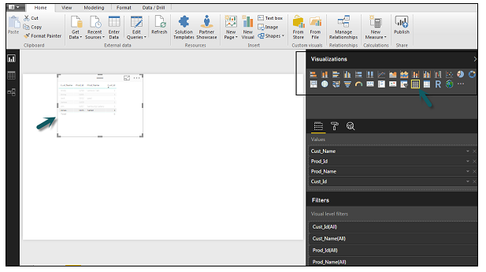

**ReportTab**

WhenyougototheDatatab, youcanseeallthedataasperthedefinedRelationshipfromthedatasources.

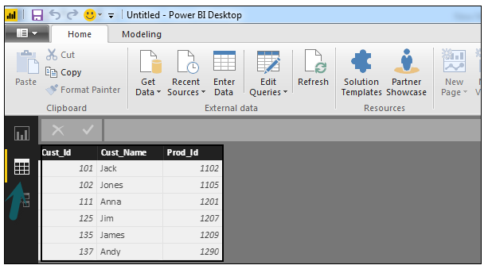

**DataTab**

IntheRelationshiptab, youcanseetherelationshipbetweendatasources. WhenyouaddmultipledatasourcestoPowerBIvisualization, thetoolautomaticallytriestodetecttherelationshipbetweenthecolumns. WhenyounavigatetotheRelationshiptab, youcanviewtherelationship. YoucanalsocreateaRelationshipbetweenthecolumnsusingCreateRelationshipsoption.

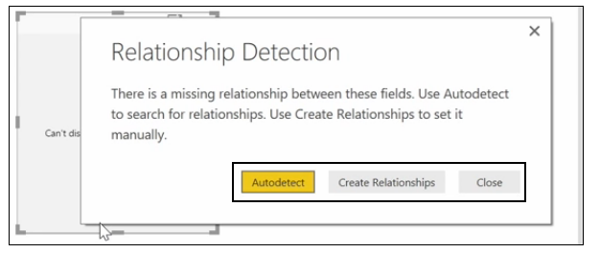

**RelationshipTab**

Youcanalsoaddandremoverelationshipsindatavisualization. Toremovearelationship, youhavetoright-clickandselectthe“Delete”option. Tocreateanew“Relationship”, youjustneedtodraganddropthefieldsthatyouwanttolinkbetweenthedatasources.

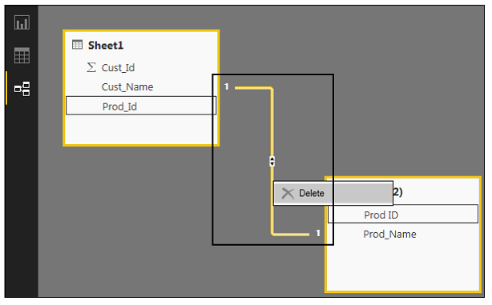

**Relationships**

YoucanalsousetheRelationshipviewtohideaparticularcolumninthereport. Tohideacolumn, right-clickonthecolumnnameandselectthe“Hideinreportview”option.

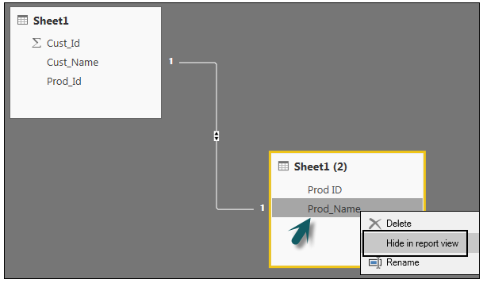

**CreatingCalculatedColumns**

YoucancreatecalculatedcolumnsinPowerBIbycombiningtwoormoreelementsoftheexistingdata. Youcanalsoapplycalculationonanexistingcolumntodefineanewmetricorcombinetwocolumnstocreateonenewcolumn.

Youcanevencreateacalculatedcolumntoestablisharelationshipbetweenthetablesanditcanalsobeusedtosetuparelationshipbetweentwotables.

Tocreateanewcalculatedcolumn, navigatetoDataViewtabontheleftsideofthescreenandthenclickModeling.

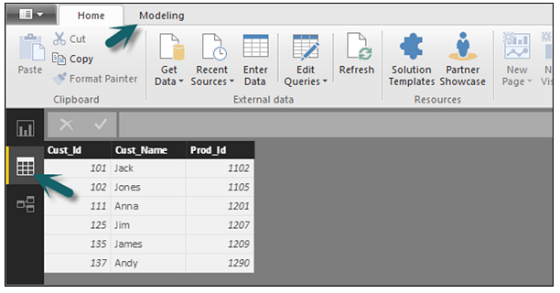

**NewCalculatedColumn**

WhenyounavigatetotheModelingtab, youcanseeaNewColumnoptionatthetopofthescreen. Thisalsoopenstheformulabar, whereyoucanenterDAXformulatoperformcalculation. DAX- DataAnalysisExpressionisapowerfullanguagealsousedinExceltoperformcalculations. YoucanalsorenamethecolumnbychangingtheColumntextintheformulabar.

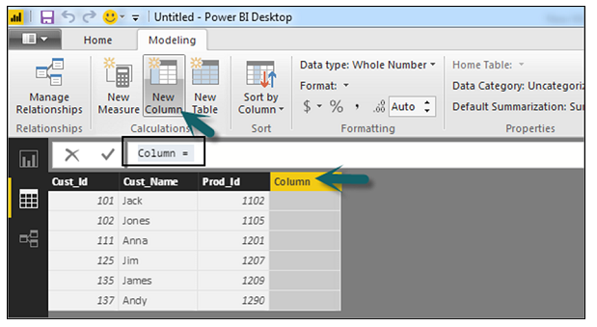

**ModelingTab**

Inthefollowingexample, letuscreateanewcolumn: ProductCode (Product_C), whichisderivedfromthelastthreecharactersofProd_Idcolumn. Then, writethefollowingformula −

Product_C = RIGHT( Sheet1[Prod_Id],3)

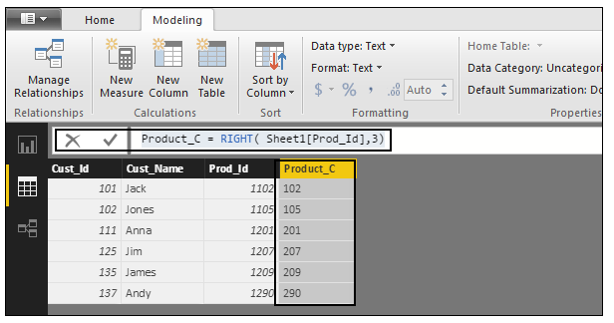

Alonglistofformulasisalsoprovidedthatyoucanuseforcreatingcalculatedcolumns. Youhavetoenterthefirstcharacterofformulatobeusedincalculationsasshowninthefollowingscreenshot.

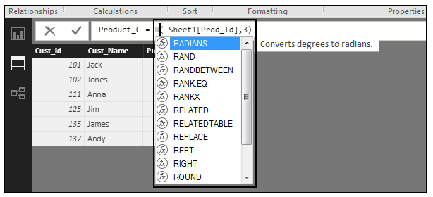

**CreatingCalculatedTables**

YoucanalsocreateanewcalculatedtableindatamodelinginPowerBI. Tocreateanewtable, navigatetotheDataViewtabontheleftsideofthescreen, andthengototheModelingoptionatthetopofthescreen.

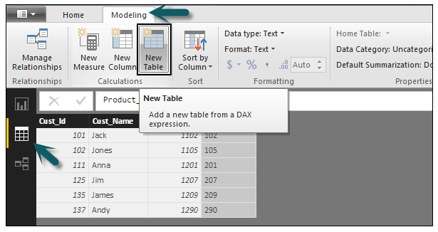

**ModelingOption**

DAXexpressionisusedtocreatethenewtable. YouhavetoenterthenameofanewtableontheleftsideoftheequalsignandDAXformulatoperformthecalculationtoformthattableontheright. Whenthecalculationiscomplete, thenewtableappearsintheFieldspaneinyourmodel.

Inthefollowingexample, letusdefineanewtable - Table_CustCthatreturnsaonecolumntablecontaininguniquevaluesinacolumninanothertable.

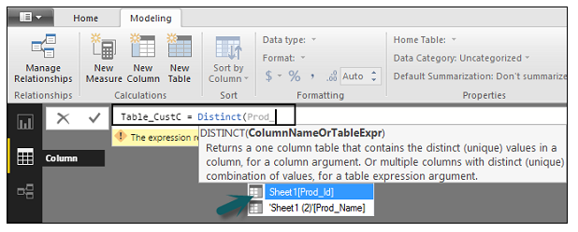

Anewtableisaddedunderthe“Fields”sectioninPowerBIscreenasshowninthefollowingscreenshot. Oncethecalculatedcolumnandcalculatedtablesarecreatedasperyourrequirement, youcanusethefieldsintheReporttabinPowerBI.

Toaddtheseobjects, youhavetoselectacheckboxandarelationshipisautomaticallydetectedifpossible. Ifnot, thenyoucandragthecolumnsthatyouwanttoconnect.

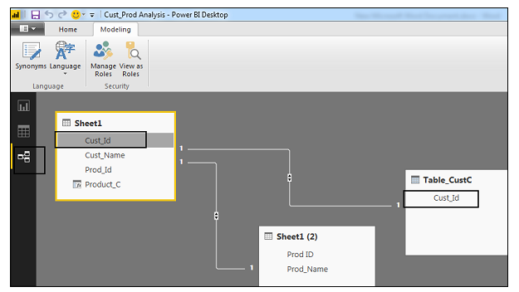

Toviewthereport, younavigatetotheReporttabandyoucanseeboth“Calculatedcolumns”andfieldsfromthenew“Calculatedtable”inthereportview.

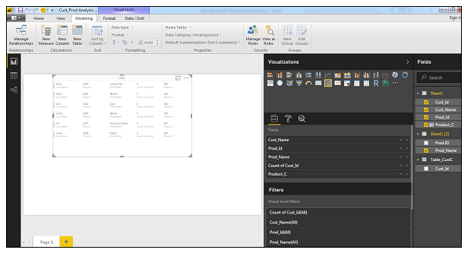

**ManagingTime-BasedData**

PowerBIallowstodrillthroughtime-baseddatabydefault. Whenyouaddadatefieldinyouranalysisandenabledrillonyourdatavisualization, ittakesyoutothenextleveloftime-baseddata.

LetusconsiderwehaveaddedTime-basedtableinPowerBIvisualization. WehaveaddedRevenueandYearcolumninourreport.

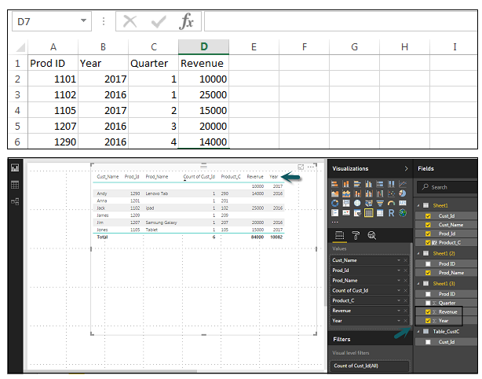

Wecanenablethedrillfeatureinvisualizationsusingtheoptionatthetop. Onceweenablethedrillfeatureandclickthebarsorlinesinthechart, itdrillsdowntothenextleveloftimehierarchy. Example: Years → Quarters → Months.

WecanalsouseGotothenextlevelinthehierarchyoptiontoperformaDrill.

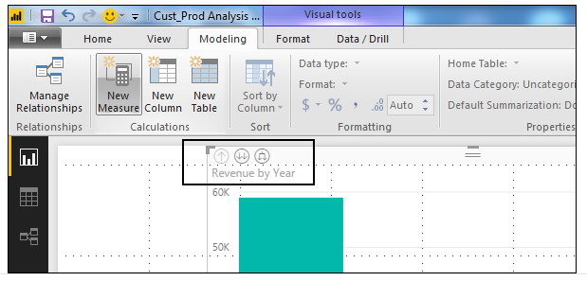

**Exploring Different Datasets**

Power BI tool provides a lot of options to explore the datasets. When you are working on your BI report or dashboards, you can use Power BI look for quick insights. Navigate to the datasets section on the left side of the tool UI, click the 3 dots (…) and click Get Insights.

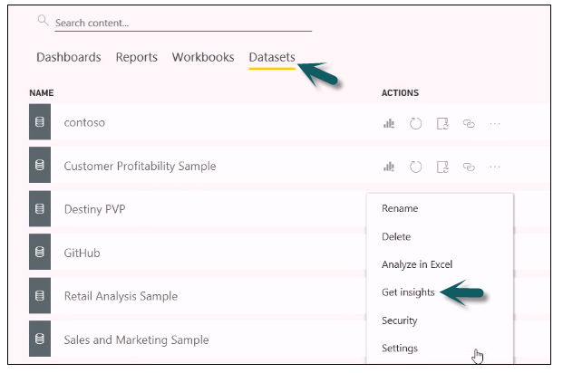

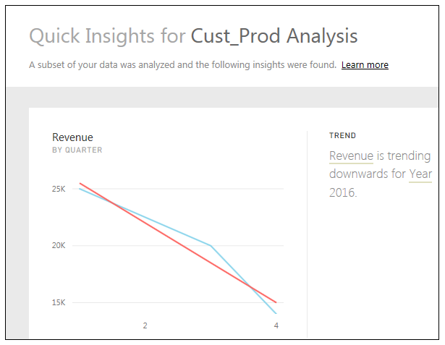

When you select the Get Insights option, it runs all the algorithms in your dataset and once it is complete, you get a notification that insight is ready for your dataset.

You can click the View Insights option and the tool will show you all chart representations of your data insights. You can any time go to this option and check insights option in your dataset.

When you publish a report to Power BI service, you also get an option of Quick Insight on the first page.

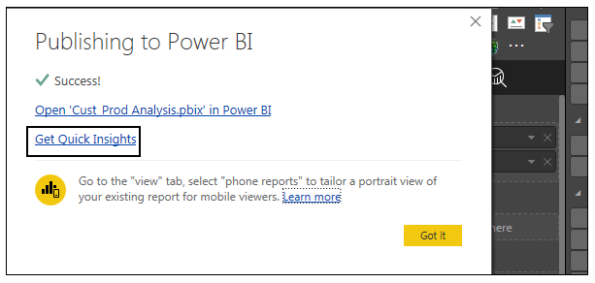

**Creating Dash Boards:**

In Power BI, you can create a dashboard by pinning visualizations from BI reports that are published using Power BI desktop. All the visualizations that are created using Power BI service are also available for pinning to create dashboards.

In Power BI, if you want to pin a visual, open the BI report on the Power BI service. At the top of the visual, select the pin icon.

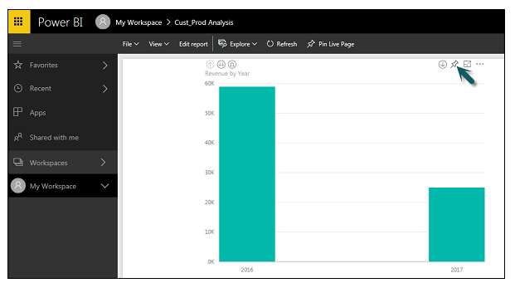

When you use the Pin option as shown as shown in the above screenshot, a new dialog box appears as shown in the following screenshot. It asks you to create a new dashboard or select an existing dashboard to put the visual from the dropdown list. If you don’t have an existing dashboard, then this option is greyed out.

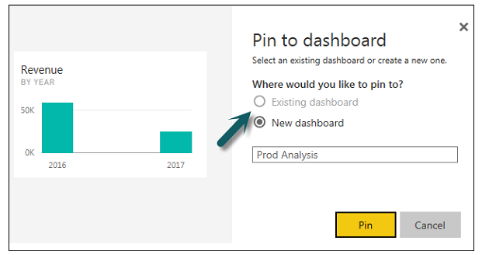

Once you click the Pin button, you will get a confirmation that your visualization is “Pinned” to the dashboard. You can click My Workspace and check the dashboard.

Once your dashboard is created, you can use different options to configure the dashboard.

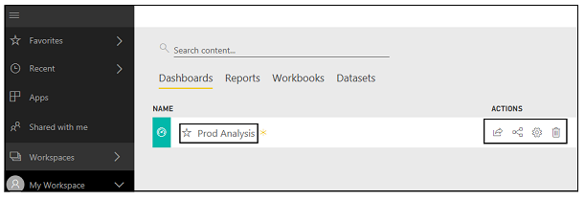

**Sharing Dashboards**

When you publish your BI report to Power BI service, you can share reports and dashboards with other users in your organization. Sharing a dashboard is very easy in Power BI.

You have to open the dashboard in Power BI service and click the Share option at the top right corner of the screen.

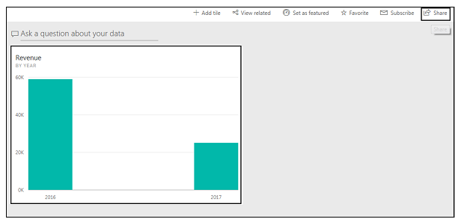

The sharing feature is only available with Power BI Pro version. You can also use the 60-days free trial for Power BI Pro as shown in the following screenshot.

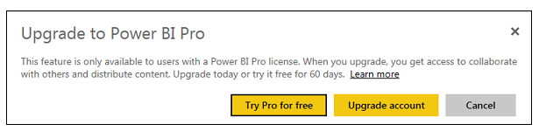

Click the Try Pro for free to start a trial. Select the Start Trial and Finish, and you will get a confirmation that 60-days trial has started. When you click the Share dashboard, you will get options in a new window. You have to enter the email Id of the user with whom you want to share this dashboard.

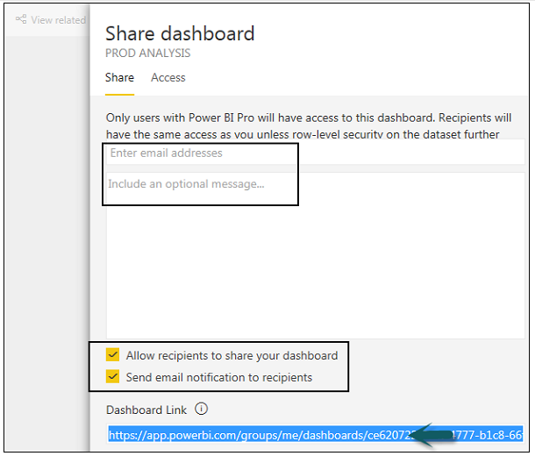

You can allow recipients to share the dashboard with other users or send email notifications. You can also provide a direct URL to users and they can access the dashboard directly.

**Tiles in Dashboard**

When you check More Options in the dashboard, you can see an option of Focus Mode and other different options in the dashboard.

**Focus Mode** is used to take a closer look at your dashboard data. When you have multiple values in the dashboard, you can use the Focus Mode for a better view of the objects in the dashboard. If there are any columns, which are not shown due to space issues, you can also view those using the Focus Mode.

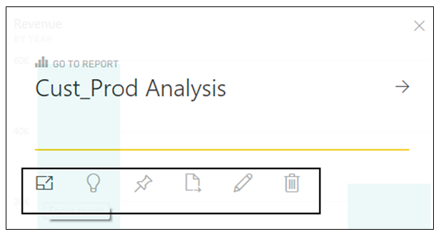

Focus Mode is used to see all the data in the dashboard/report. It is also possible to pin the visual directly from Focus Mode to a different dashboard by selecting the Pin icon.

To exit the Focus Mode, you can select the Exit Focus Mode option.



You can also use the Tile Details option to edit few formatting changes. This option allows to change the tile's title, subtitle, last refresh time and date, and other details, such as creating a custom link for your dashboard.

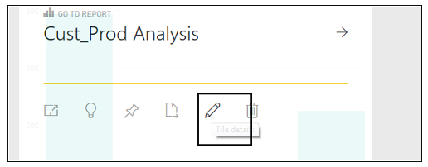

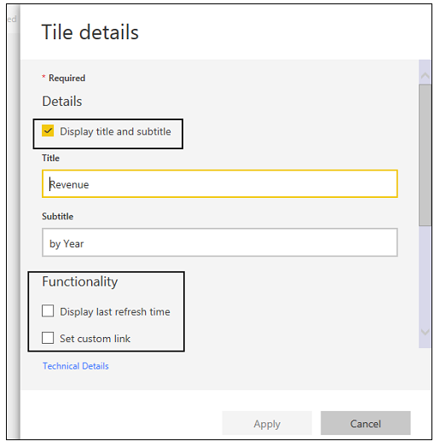

**Data Gateway**

You can connect on-premise data sources to Power BI service using a data gateway. You can also use a version of data gateway that doesn’t include any administration configuration and it is called as Personal Gateway.

You can set up Personal Gateway by logging into Power BI service. You have to select the download icon on the top right hand corner of the screen and click Data Gateway.

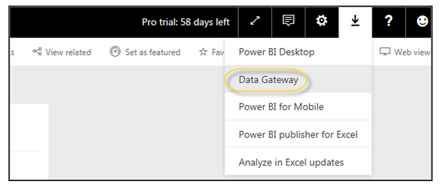

As per Power BI official site, using Data Gateway with the on-premises gateways, you can keep your data fresh by connecting to your on-premises data sources without the need to move the data. Query large datasets and benefit from your existing investments. The gateways provide the flexibility you need to meet individual needs, and the needs of your organization.

**Power BI - Visualization Options**

Creating Simple Visualizations

Visualizations are used to effectively present your data and are the basic building blocks of any Business Intelligence tool. Power BI contains various default data visualization components that include simple bar charts to pie charts to maps, and also complex models such as waterfalls, funnels, gauges, and many other components.

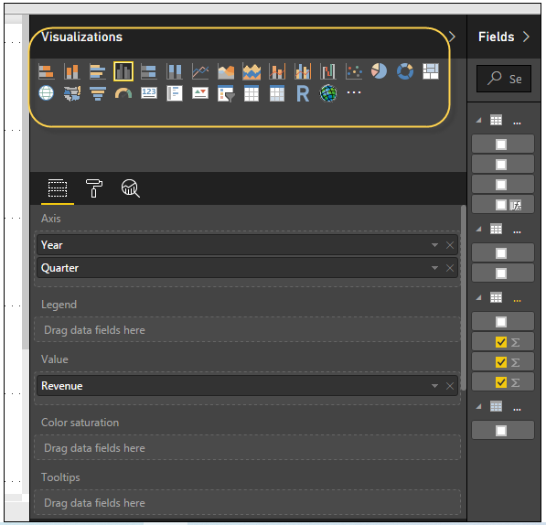

In Power BI, you can create visualization in two ways. First is by adding from the right side pane to Report Canvas. By default, it is the table type visualization, which is selected in Power BI. Another way is to drag the fields from right side bar to the axis and value axis under Visualization. You can add multiple fields to each axis as per the requirement.

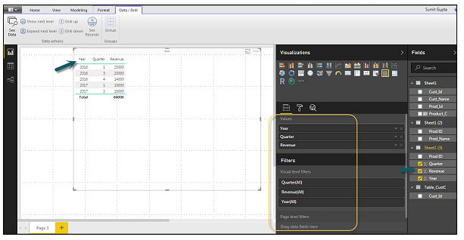

In Power BI, it is also possible to move your visualization on the reporting canvas by clicking and then dragging it. You can also switch between different type of charts and visualizations from the Visualization pane. Power BI attempts to convert your selected fields to the new visual type as closely as possible.

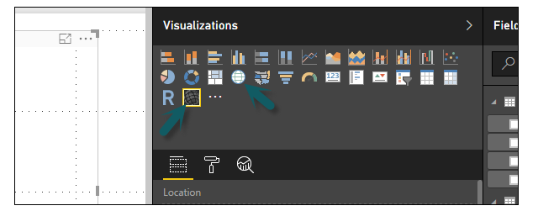

In Power BI, we have two types of map visualization - bubble maps and shape maps. If you want to create a bubble map, select the map option from the visualization pane.

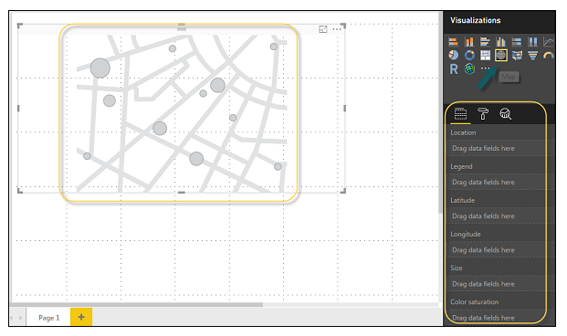

To use a bubble map, drag the map from Visualizations to the Report Canvas. To display values, you have to add any location object to the axis.

Display Values

In the value fields, you can see that it accepts values axis such as City and State and or you can also add longitude and latitude values. To change the bubble size, you need to add a field to the value axis.

You can also use a filled map in data visualization, just by dragging the filled map to the Report Canvas.

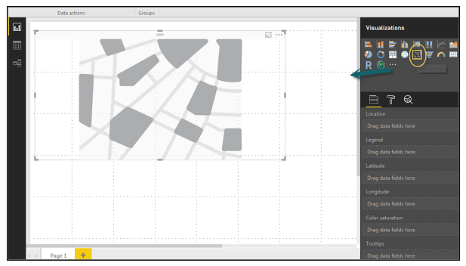

Note − If you see a warning symbol on top of your map visualization, it means that you need to add more locations to your map chart.

**Using Combination Charts**

In data visualization, it is also required to plot multiple measures in a single chart. Power BI supports various combination chart types to plot measure values. Let us say you want to plot revenue and unit_solds in one chart. Combination charts are the most suitable option for these kind of requirement.

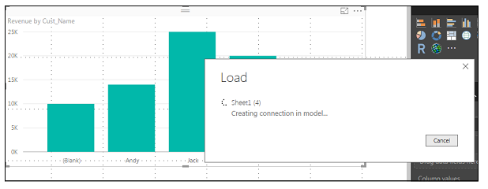

One of the most common Combination chart in Power BI is Line and Stacked column charts. Let us say we have a revenue field and we have added a new data source that contains customer-wise unit quantity and we want to plot this in our visualization.

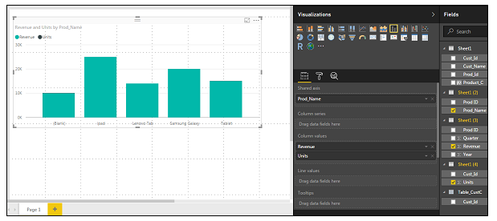

Once you add a data source, it will be added to the list of fields on the right side. You can add units to the column axis as shown in the following screenshot.

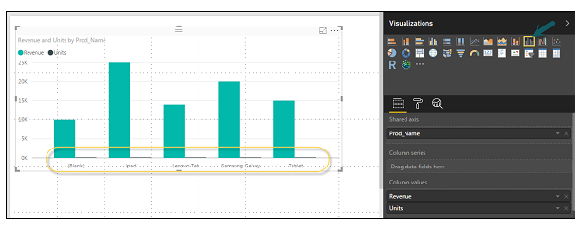

You have other type of combine chart that you can use in Power BI - Line and Clustered Column.

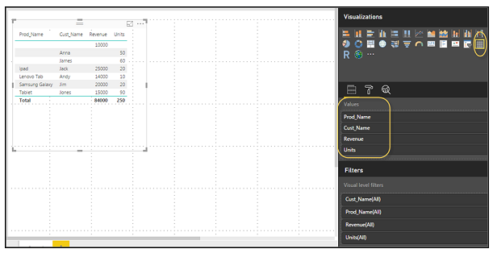

**Using Tables**

In Power BI, when you add a dataset to your visualization, it adds a table chart to the Report canvas. You can drag the fields that you want to add to the report. You can also select the checkbox in front of each field to add those to the Report area.

With the numerical values in a table, you can see a sum of values at the bottom.

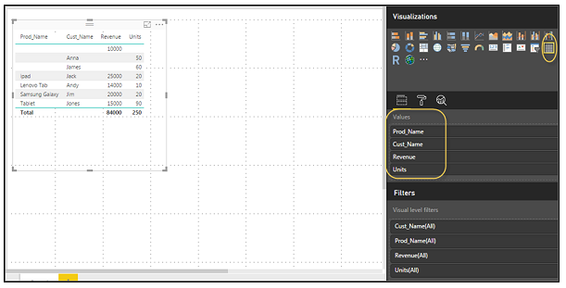

You can also perform a sort in the table using an arrow key at the top of the column. To perform ascending/descending sort, just click the arrow mark, and the values in the column will be sorted.

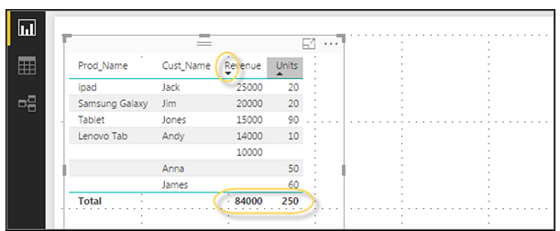

The order of the columns in a table is determined by the order in the value bucket on the right side. If you want to change the order, you can delete any column and add the other one.

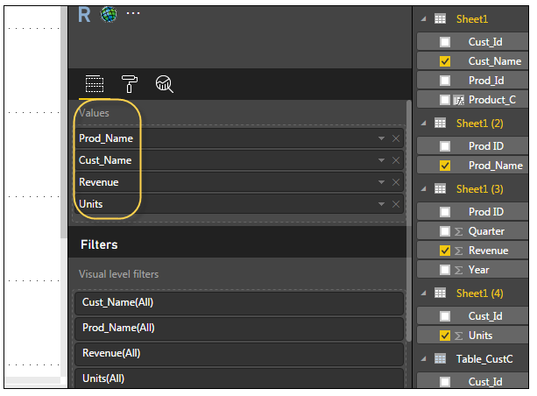

You can also undo summarize or apply different aggregate function on numerical values in the table. To change the aggregation type, click the arrow in the value bucket in front of the measure and you will see a list of formulas that can be used.

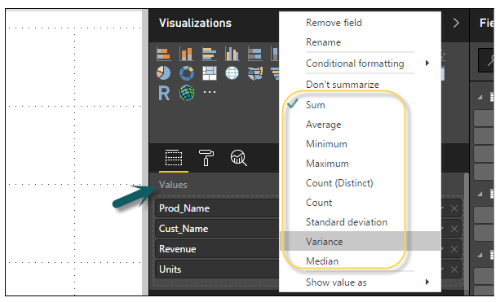

Another table type in Power BI is the matrix table that provides a lot of features such as auto sizing, column tables, and setting colors, etc.

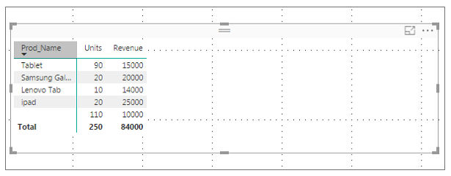

**Modify Colors in Charts**

In Power BI, you can also modify the colors in the chart. When you select any visualization, it has an option to change the color. Following options are available under the Format tab −

Legend

Data Colors

Detail Label

Title

Background

Lock Aspect

Border

General

To open these options, go to the Format tab as shown in the following screenshot. Once you click, you can see all the options available.

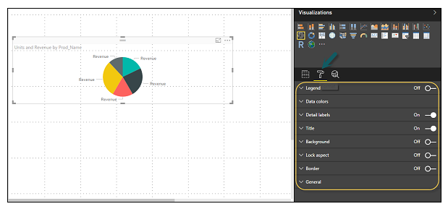

When you expand the Legend field, you have an option where you want to display the legend. You can select −

Position

Title

Legend Name

Color

Text Size

Font Family

Legend Field,

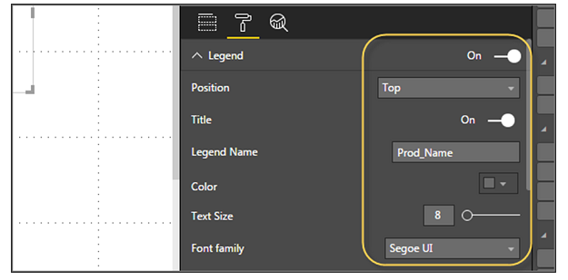

Similarly, you have data colors. In case, you want to change the color of any data field, you can use this option. It shows all objects and their corresponding colors in the chart.

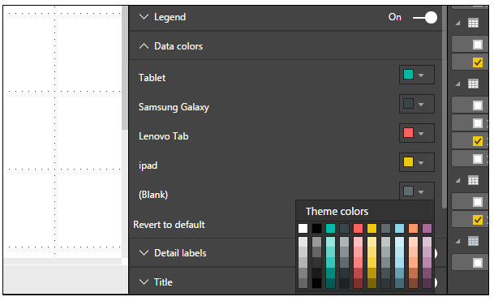

You also have Analytics feature in the tool, where you can draw lines as per requirement in data visualization. You have the following line types in data visualization −

Constant Line

Min Line

Max Line

Average Line

Median Line

Percentile Line

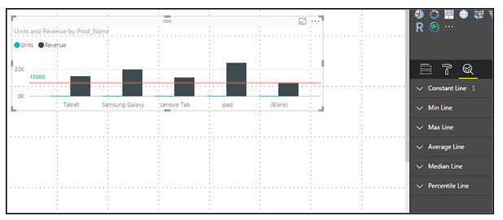

You can opt for a dashed, dotted, or a solid line. You can select Transparency level, color, and position of the line. You can also switch on/off data label for this line.

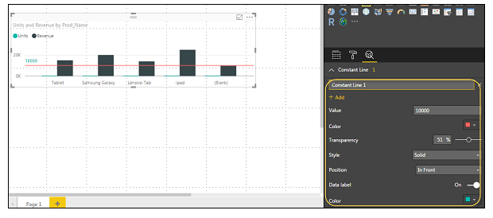

**Adding Shapes, Images and Text box**

Sometimes it is required that you need to add static text, images, or shapes to your visualization. In case you want to add header/footer or any static signatures, messages to data visualization this option can be used.

You can also add URLs in the text box and Power BI uses those link to make it live.

To add shapes, images and text box, navigate to the Home tab and at the top you will find an option to add images.

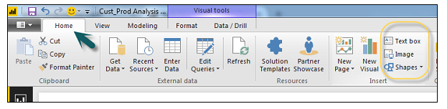

You can insert different shapes in data visualization. To see the available shapes, click the arrow next to the Shapes button.

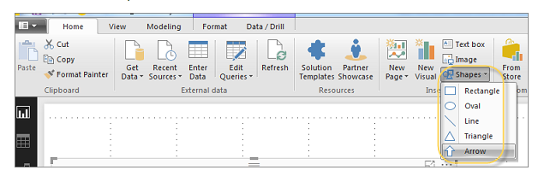

When you click on the text box, it adds a text box in your Report canvas. You can enter any text in the text box and use the rich text editor to make formatting changes.

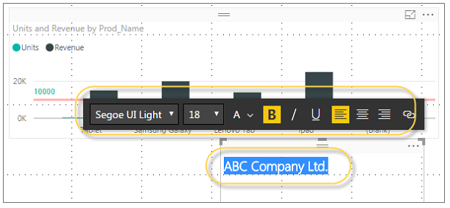

Similarly, images can be added to data visualization to add logos or other images to data visualization. When you click the Image option, it asks for a path to pass the image file.

You can add shapes by selecting any shape from the dropdown list. You can also resize it using different options.

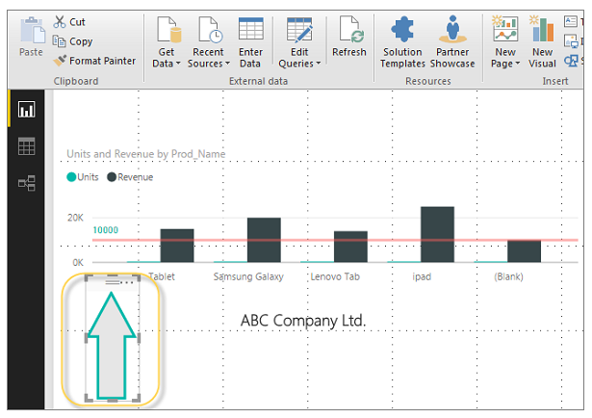

**Styling Reports**

In Power BI, you have flexible options to adjust the page layout and formatting such as orientation and page size of your report. Navigate to Page View menu from the Home tab and the following options are provided.

Fit to Page

Fit to Width

Actual Size

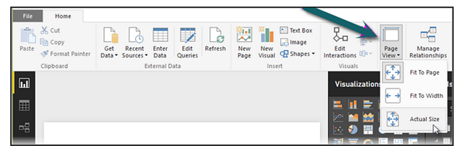

By default, the page size in a report is 16:9; however, it is also possible to change the page size of the report. To change the page size, navigate to the Visualization pane and select Paint brush.

Note − To change page size, no visualization should be added to the Report canvas. You have the following options available under Page layout −

Page Information

Page Size

Page Background

Under Page Information, you have Name and Q&A.

Under Page Size, you can select from the following options −

Type

Width

Height

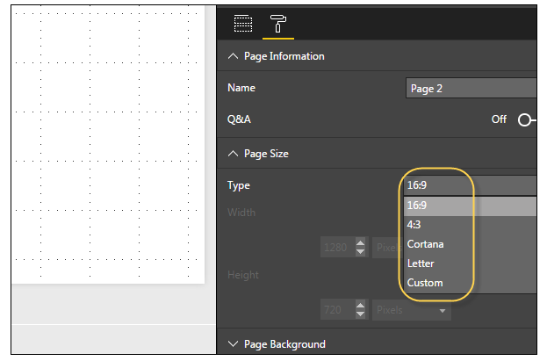

Under Page Background, you can select from the following options:

Color

Transparency

Add Image

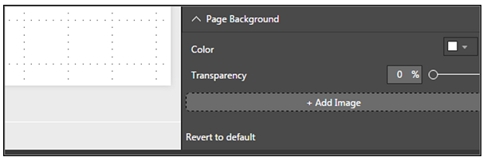

**Duplicating Reports**

In some scenarios, you may want to use the same layout and visuals for different pages. Power BI provides an option to create a copy of the page. When you use Duplicate Page option, a new page is added with similar layout and visuals.

To duplicate a page, right-click the Page and select Duplicate Page option. This will create a copy of the same page with the name - Duplicate of Page1.

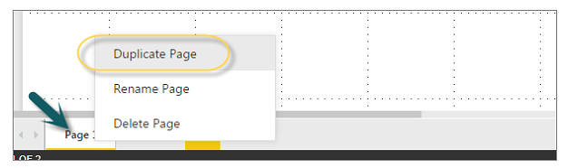

Now, if you want to rename an existing page or delete a page, you can use other options as shown in the above screenshot.

**Using Excel Data**

Using Power BI, you can also import Excel workbook file from the local drive into Power BI. To import data from the excel sheet, you have to ensure that each column has a proper name. To import an Excel file in Power BI, navigate to Get Data → Files → Local Files.

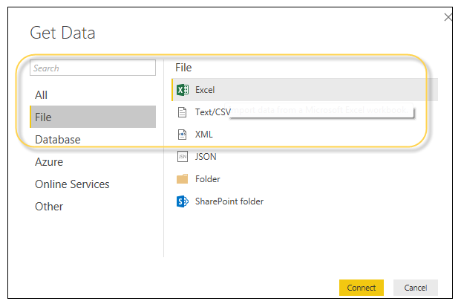

In Power BI Service, navigate to My Workspace → File → Local File.

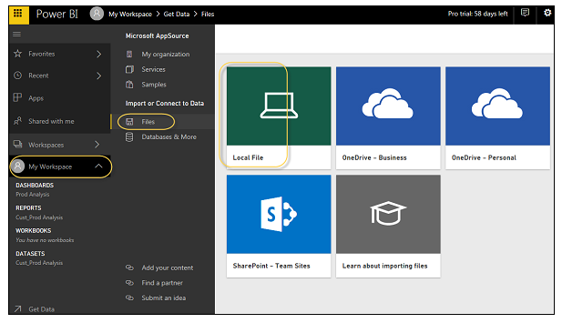

Also note that it is not necessary your Excel file should only be saved on the Local Drive. You can also import an Excel workbook from OneDrive or even from SharePoint.

Once the dataset is imported, you are ready to create the reports in Power BI. Imported dataset is available under “DATASETS” option in Power BI menu.

Double-click Datasets. Then, navigate to the Explore tab. This will open a new Report Canvas. All the fields from your table and corresponding columns are available under the Fields option on the right side of the screen.

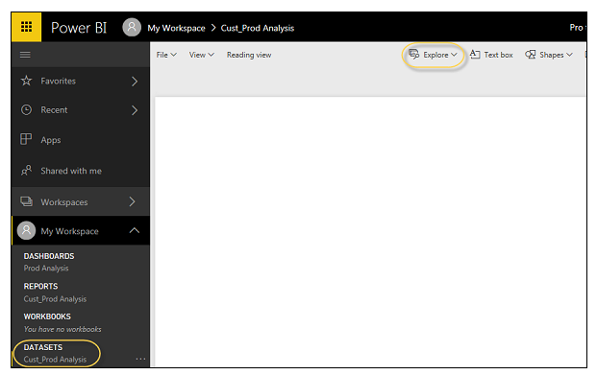

To create a report, select any visualization and add the fields from the table to visualization.

**DAX Introduction**

DAX (Data Analysis Expressions) is a formula expression language and can be used in different BI and visualization tools. DAX is also known as function language, where the full code is kept inside a function. DAX programming formula contains two data types: Numeric and Other. Numeric includes - integers, currency and decimals, while Other includes: string and binary object.

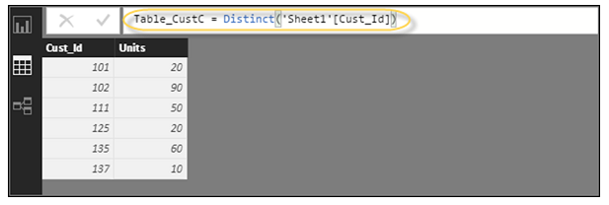

Following is an example of DAX formula, which uses a function to calculate a column in a table.

**DAX Formula**

DAX function can also include other functions, conditional statements, and value references.

**DAX Functions**

In Power BI, you can use different function types to analyze data, and create new columns and measures. It includes functions from different categories such as −

Aggregate

Text

Date

Logical

Counting

Information

Power BI provides an easy way to see the list of all functions. When you start typing your function in the formula bar, you can see the list of all functions starting with that alphabet.

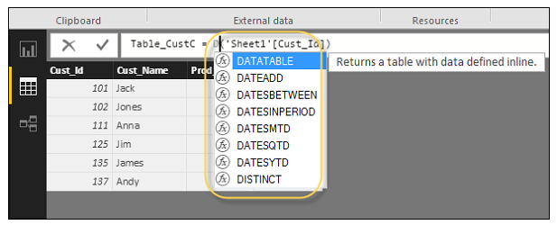

**Aggregate Functions**

DAX has a number of aggregate functions.

MIN

MAX

Average

SUM

SUMX

Counting Functions

Other counting functions in DAX include −

DISTINCTCOUNT

COUNT

COUNTA

COUNTROWS

COUNTBLANK

Logical Functions

Following are the collection of Logical functions −

AND

OR

NOT

IF

IFERROR

TEXT Functions

REPLACE

SEARCH

UPPER

FIXED

CONCATENATE

DATE Functions

DATE

HOUR

WEEKDAY

NOW

EOMONTH

INFORMATION Functions

ISBLANK

ISNUMBER

ISTEXT

ISNONTEXT

ISERROR

DAX Calculation Types

In Power BI, you can create two primary calculations using DAX −

Calculated columns

Calculated measures

When you navigate to the Modeling tab, you can see a New Column option at the top of the screen. This also opens the formula bar where you can enter DAX formula to perform the calculation. DAX - Data Analysis Expression is a powerful language used in Excel to perform calculations. You can also rename the column by changing the Column text in the formula bar.

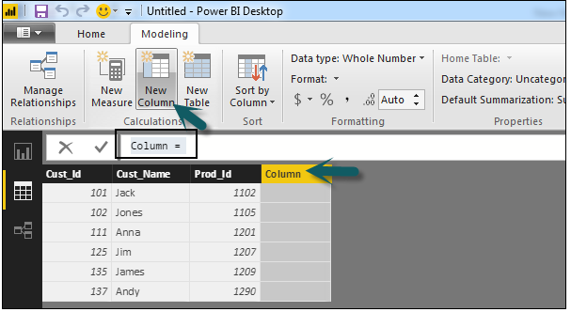In the following example, we have created a new column: Product Code (Product_C), which is derived from the last 3 characters of Prod_Id column. Following is the formula −

Product_C = RIGHT( Sheet1[Prod_Id],3)

To create a calculated measure, navigate to New Measure tab under Modeling. This will add a new object under the Fields tab with the name Measure.

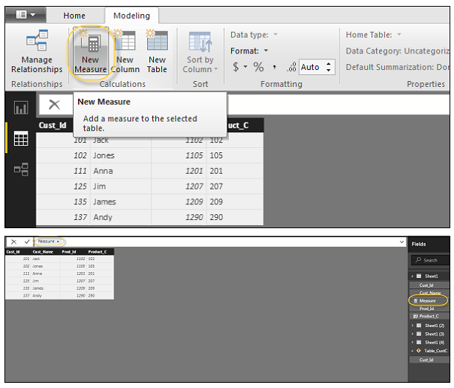

You can write DAX formula to calculate the value of the new measure, as we did for the new calculated column.

**Assignments**

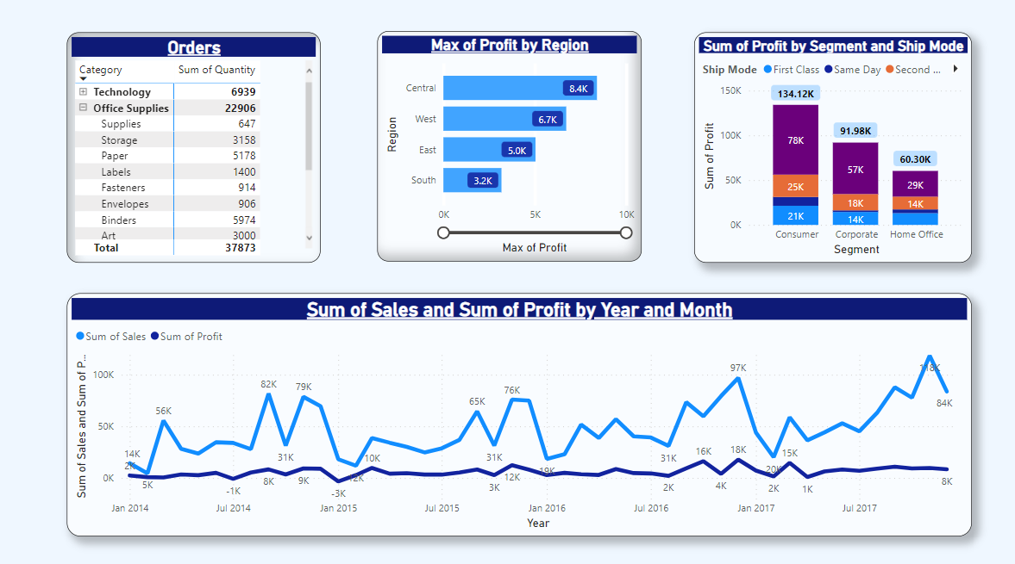

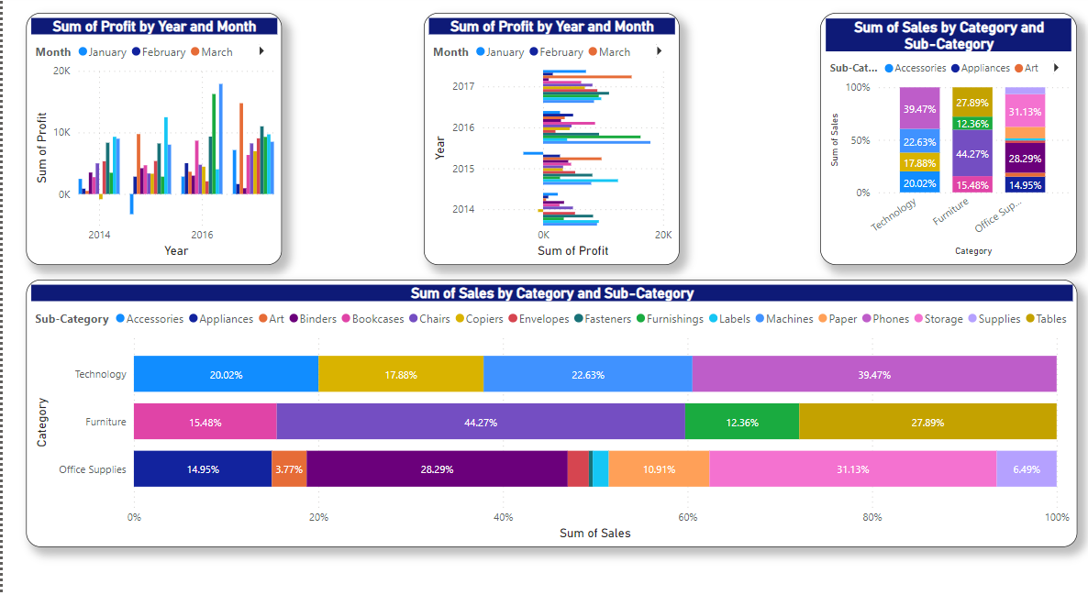

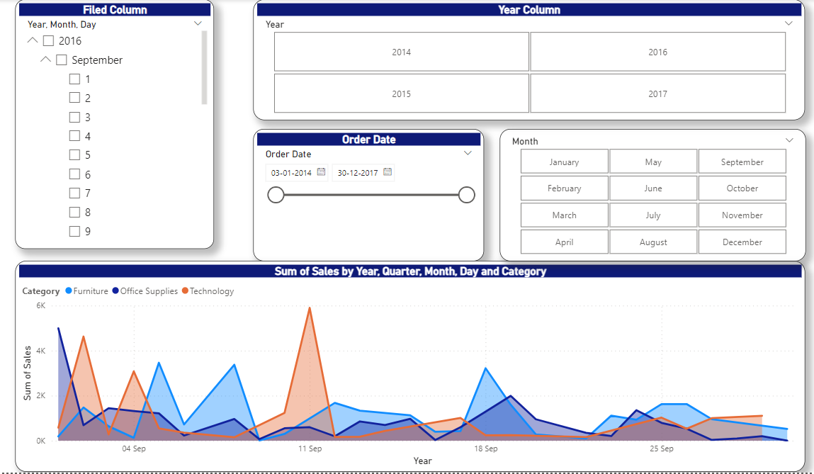

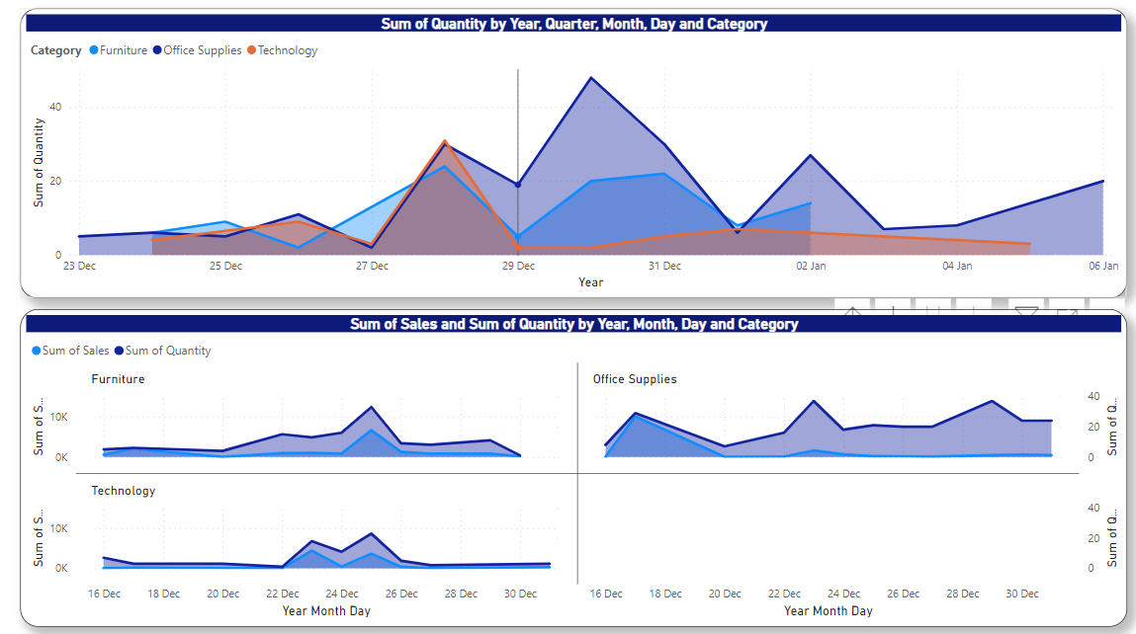

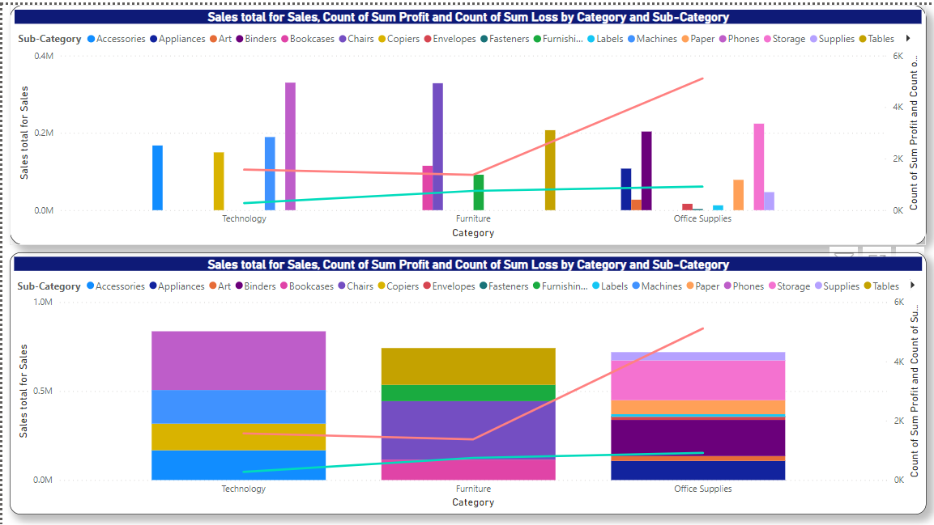

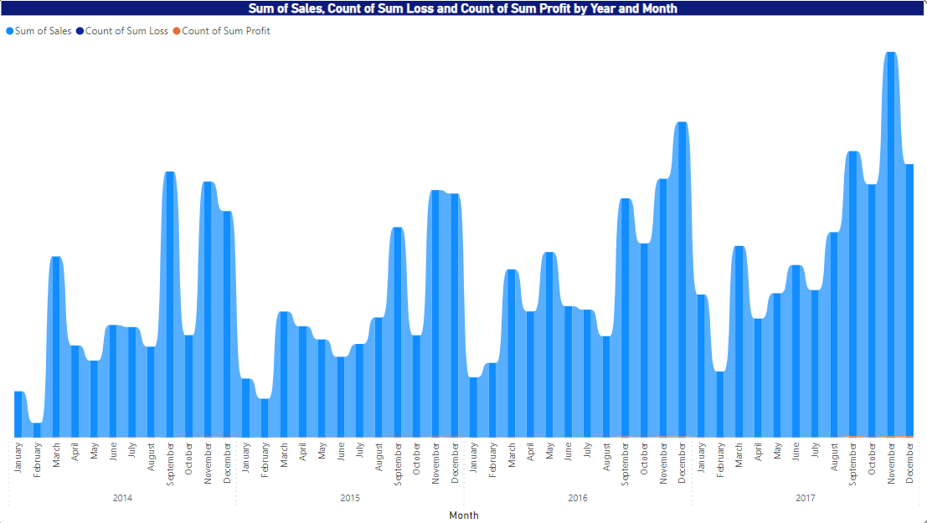

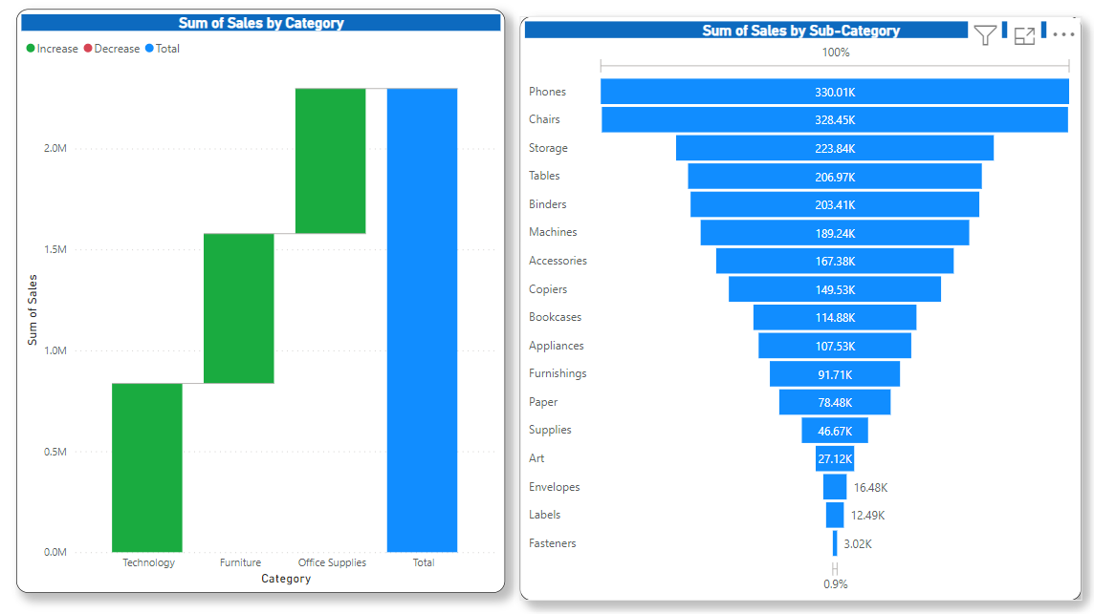

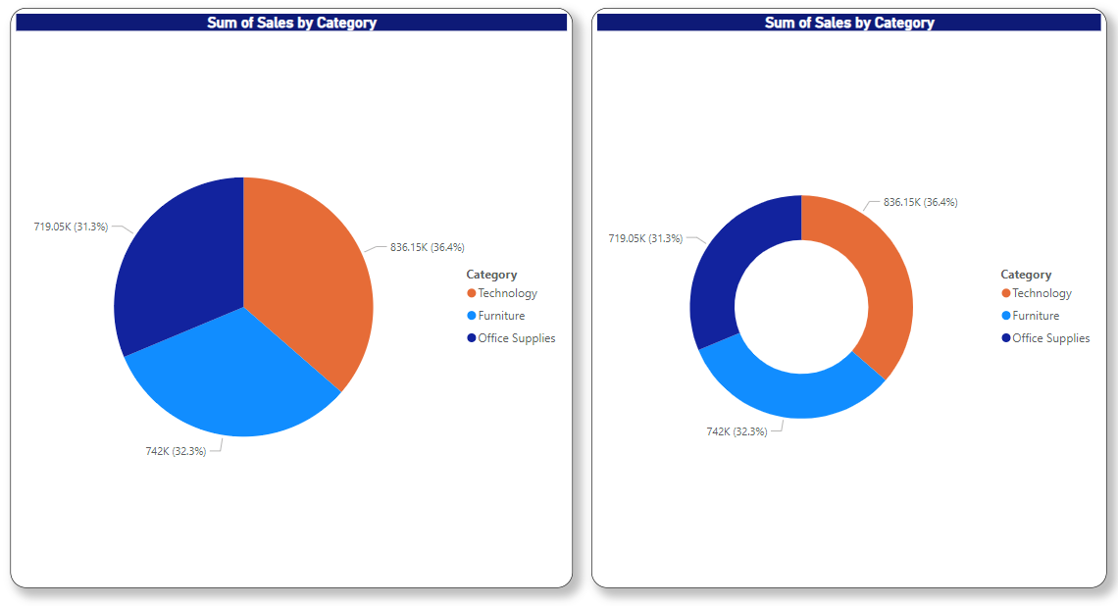

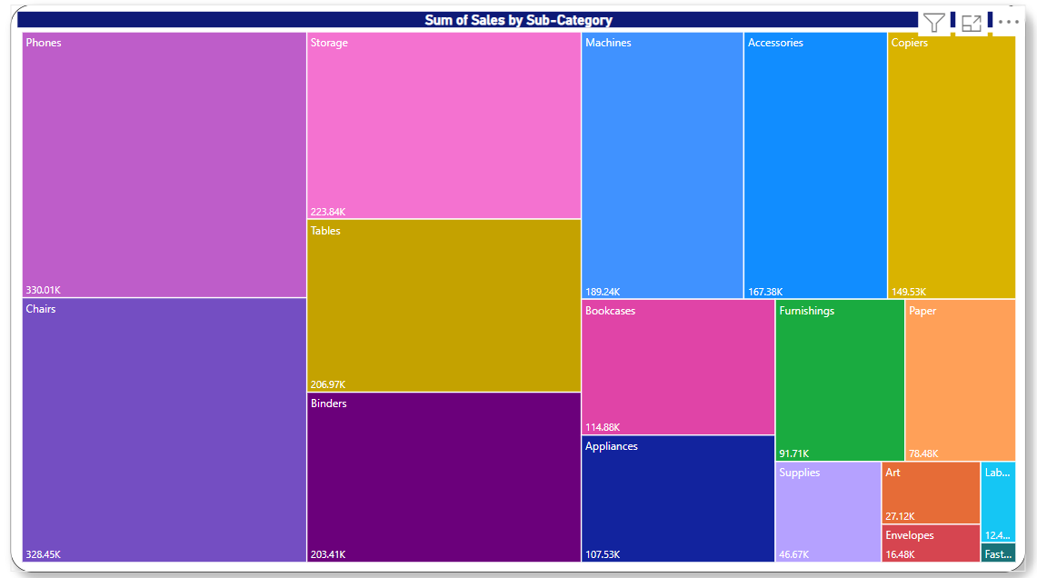

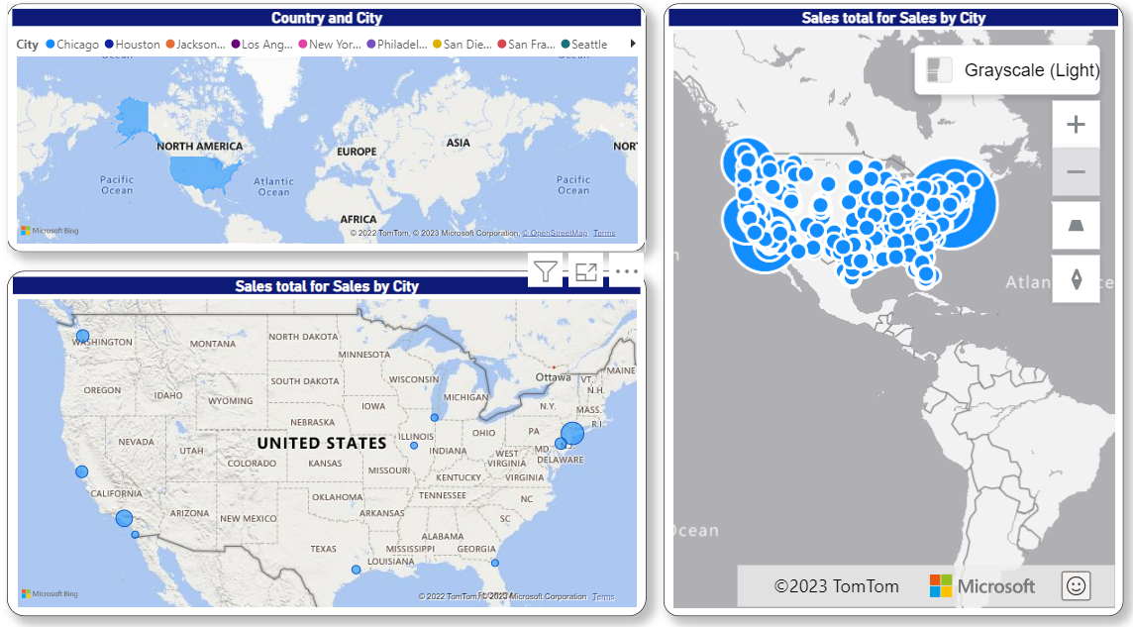

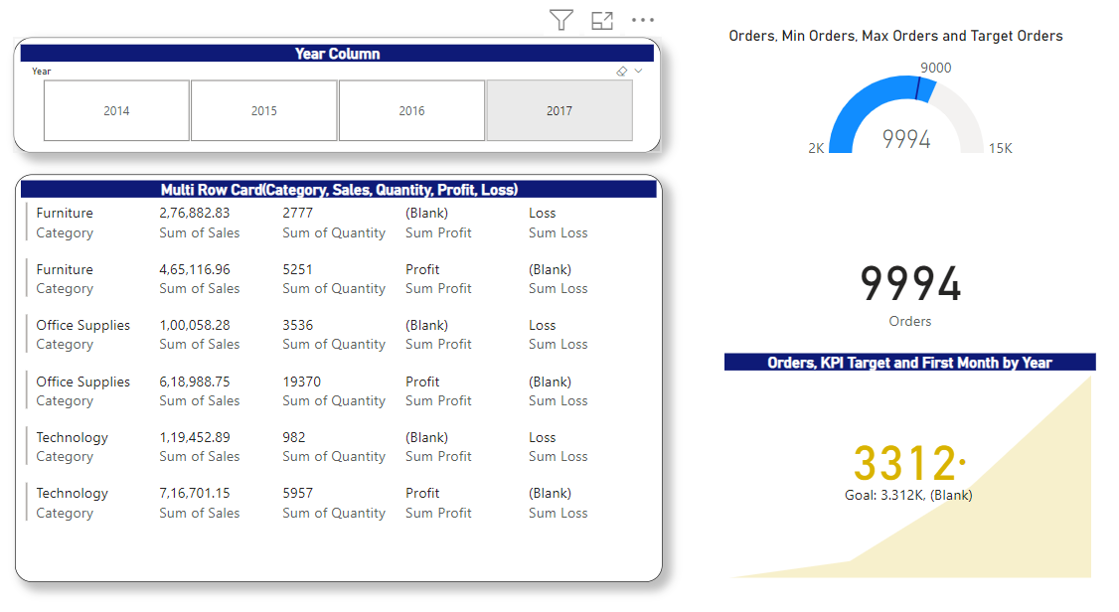

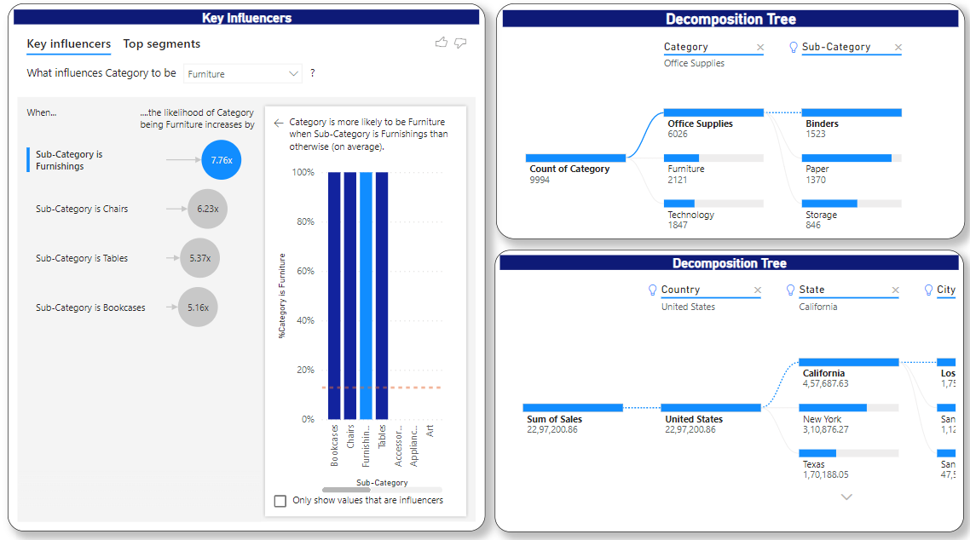

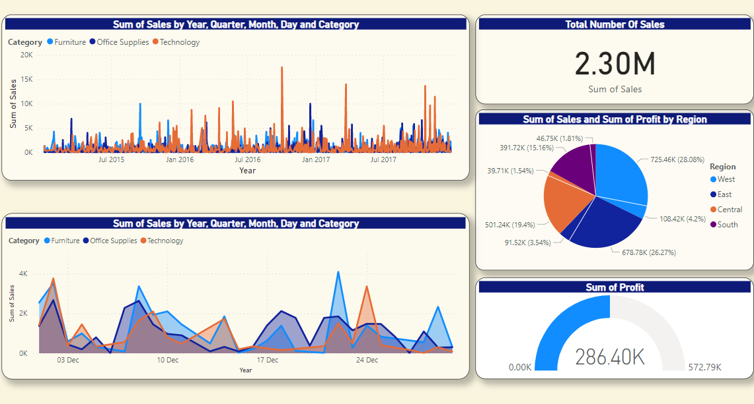

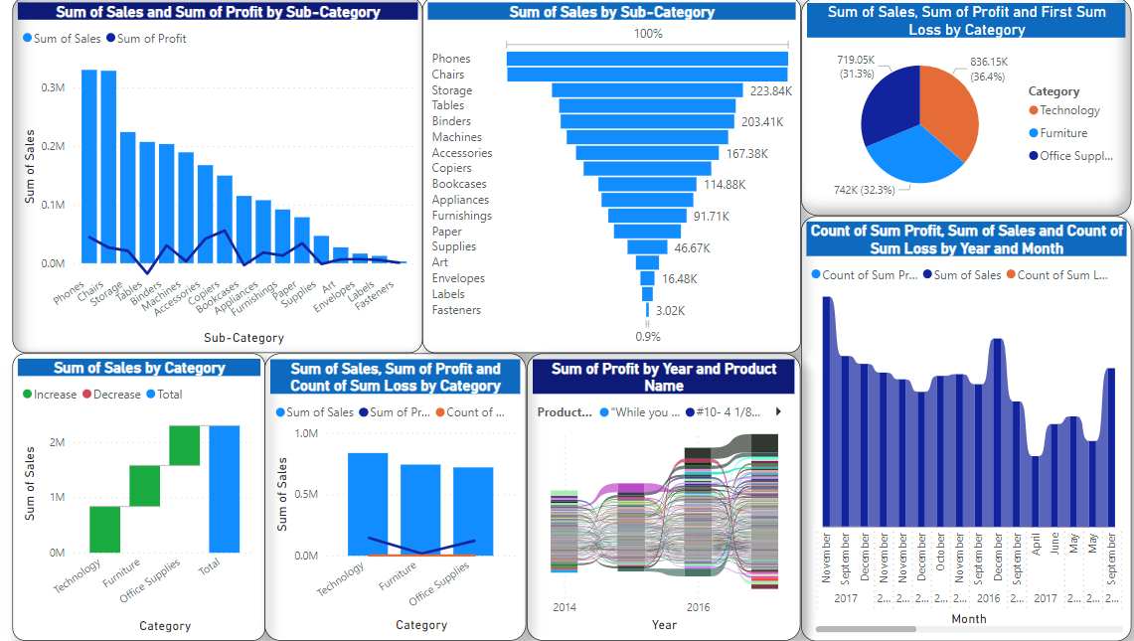

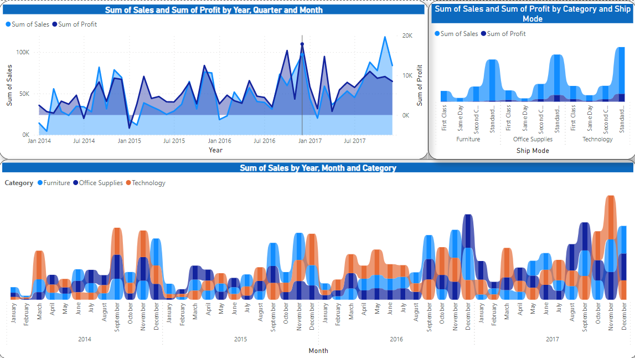

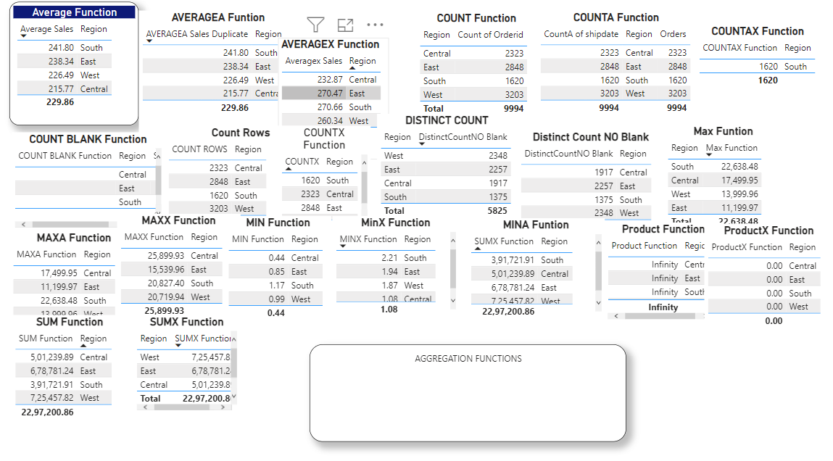

**SQL & DBEAVER**

The installation process depends on the distribution type and your Operational System.

**Windows / MacOS Installer:**

The installer distribution is the recommended way to install SQL and SQL and DBeaverin Windows and MacOS X. It contains all required dependencies.

In addition, the installer automatically upgradesSQLand SQL and DBeaverto the new version if a previous version has already been installed. To install

SQL and SQL and SQL and DBeaver, run the installer executable and follow the instructions on its screens.

**NOTE:**

The installer does not change any system settings or the Java installation.

The included JDK will be accessible only to SQL and SQL and DBeaver.

**ZIP Archive:**

When installing SQL and SQL and DBeavermanually, without using an installer:

1. Extract the contents of the archive.

NOTE: Do not unzip the archive over a previous SQL and DBeaverversion. If you already have any version of SQL and DBeaverextracted in the

same location - remove it before unzipping the new version.

NOTE: All configurations, scripts and other necessary data are stored in a separate location (usually in the user`s home directory)

so the program deinstallation does not affect them.

2. Run the dbeaver executable.

**Debian Package:**

To install SQL and DBeaverusing a Debian package:

1. Run sudodpkg -idbeaver-<version>.deb .

2. Execute dbeaver& .

**RPM Package:**

To install SQL and DBeaverusing RPM package:

1. Run sudo rpm -ivhdbeaver-<version>.rpm .

2. Execute dbeaver& .

NOTE: To upgrade SQL and DBeaverto the next version, use sudo rpm -Uvhdbeaver-<version>.rpm parameter.

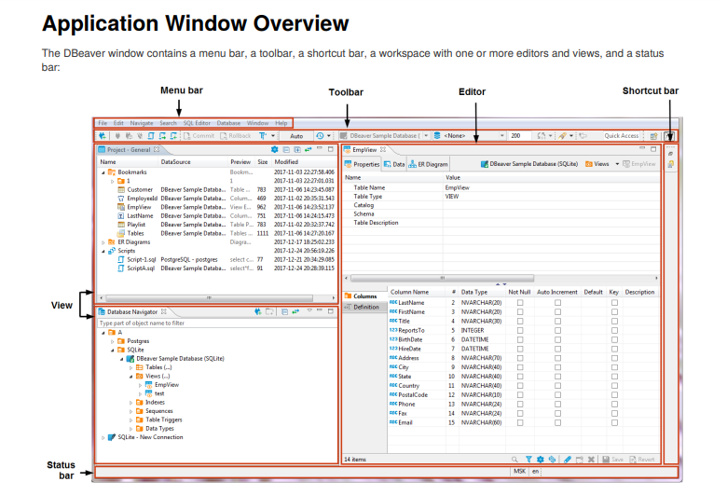

**Menu Bar:**

By default, the menu bar contains the following menus:

**File menu** contains menu items for the creation of files, folders, projects, database connections, database projects, and ER diagrams as well as Import and Export items.

**Edit** menu contains global commands like Cut, Copy, Paste, and Delete targeted at the active element.

**Navigate** menu allows navigation through scripts and database objects.

**Search menu** provides options to search among files, database objects and across data.

**SQL** Editor menu is for opening SQL Editor and managing its appearance.

**Database menu** allows management of database drivers, connections and transactions, as well as reconnecting to and disconnecting from a database.

**Window menu** includes items to manage the look of SQL and DBeaverwindow: show/hide and minimize/maximize views and editors,

display bars, split editors, and manage other preferences.

Help menu contains links to information and help resources, as well as menu items to check the version number and availability of updates.

You can customize the menu bar and the list of menu items to display, for this, go to Window -> Customize Perspective -> Menu Visibility tab.

**Toolbar:**

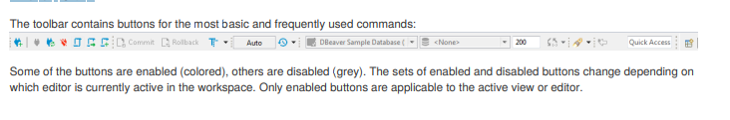

You can customize the toolbar, for this, go to Window -> Customize Perspective -> Tool Bar Visibility tab.

You can hide or show the toolbar in the application window. To do it, go to the Window menu, click Appearance -> Hide Toolbar /Show Toolbar.

**Shortcut Bar:**

There are two shortcut bars - one on the left and one on the right side of the workspace zone. Shortcut bars host shortcuts of views

and editors and appear if at least one view or editor is minimized, otherwise they are hidden.

**Workspace: Views and Editors:-**

Views are windows within the workspace that provide presentations and ways to navigate the information. For more information about particular views, see Views article.

Editors are windows in which you can interact with the content of files and databases. For more information about particular editors, see the Editors article.

Both views and editors can appear as separate windows or as tabs stacked with other views/editors in a tabbed window. The following

image shows the title bar of a tabbed window. If tabs do not fit in the title bar of a tabbed window, they become hidden. To see the list of hidden tabs, click the Show List icon that also indicates their number:

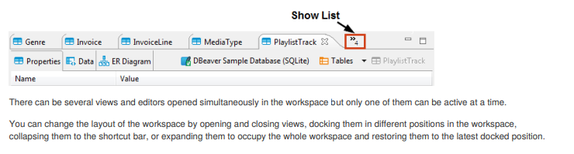

**Changing Workspace Layout:**

You can move views and editors around the workspace and dock them in different positions:

1.As a tab in a tabbed window

2.As a separate window with a vertical or horizontal layout in any zone of the workspace

You can also swap locations of two views or editors.

To dock a view to a position in the workspace, press and hold the title bar of the view, then drag and drop it onto the desired position.

You can resize the view and editor windows. To resize, place the cursor to the border of the window until it changes to a double-ended

arrow, then click and drag the border to the needed size.

To close a view or editor, click the Close button, or right-click the title bar of the view / editor, then click one of the options on the

context menu (they change depending on the configuration of windows):

**Close** - to close the active window or tab in a tabbed window

**Close Others** (for editors and views that appear as tabs in tabbed windows) - to close all tabs of the current tabbed window except the active tab

**Close Tabs to the Right / Left (also for tabbed windows) -** to close all tabs of the current tabbed window that are located to the

**right / left** of the active tab

**Close All** - to close all tabs of a tabbed window (close the window)

**Maximizing, Minimizing and Restoring View and Editors:**

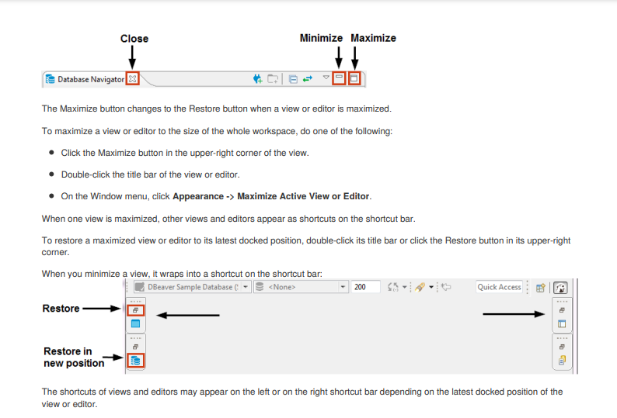

To minimize a view, do one of the following:

1.Click the Minimize button in the upper-right corner of the view.

2.On the Window menu, **click Appearance -> Minimize Active View or Editor.**

To restore a minimized view or editor to its previous position, click the Restore button on its shortcut in the shortcut bar. To restore a

minimized view or editor to a new position, click the view / editor name button under the restore button

**Views:**

Views are windows within the workspace that provide presentations and ways to navigate the information. The main views in SQL and DBeaverare: Database Navigator, Projects and Project Explorer.

**To open a view:**

On the Window menu, click **Show View** and then, on the submenu, click the name of the view. Click **Other** if the view is not visible on the submenu.

For Database Navigator, Projects, and Project Explorer views, on the Window menu, just click the name of the view.

Some views open on demand, for example the Search view opens to show search results.

Views provide their own toolbar and menu:

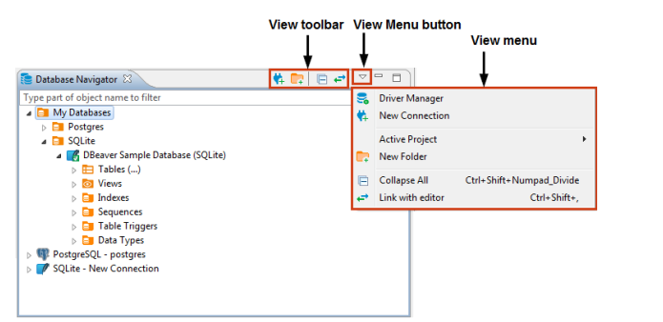

To open the view menu, click the View Menu button in the upper-right corner of the view's title bar, next to the Minimize button.

The toolbar contains buttons applicable to the objects displayed in the view. The set of enabled and disabled buttons depends on the

object in focus.

Views also provide context menus for objects they display. To open a context menu for an object, right-click the object.

**Database Navigator**

Database Navigator is the main view to work with the structure and content of databases.

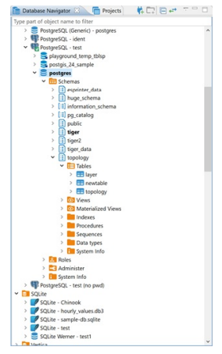

Database Navigator contains a tree of objects, a toolbar and View menu which contain generic items. Each object in the tree has its own context menu. The tree contains the following objects:

Folders - 



Database connections -  and other (icons differ depending on the database type)



Database objects - various depending on the database type, such as Tables , Views , Columns , Indexes , etc.



To open the view menu of Database Navigator, click the View Menu button () in the upper-right corner of the window. For more information on where to find the view toolbar and menu, please see the [Views](\l%20)article.

The menu contains the following items:

|  |  |  |  |
| --- | --- | --- | --- |
| **Icon** | **Menu item** | **Description** |  |
|  |  |  |  |
|  | **Driver** | Opens the Driver Manager window that allows you to create, edit and delete drivers for databases. |  |
|  | **Manager** | See [Database Drivers](\l%20)for information about managing database drivers. |  |
|  |  |  |  |
|  | **New** | Opens the Create new connection wizard. See [Create Connection](\l%20)for information about creating |  |
|  | connections. |  |
|  | **Connection** |  |
|  |  |  |
|  |  |  |  |
| (empty) | **Active** | Displays a submenu which allows you to choose a project. See [Projects](\l%20)and [Projects view](\l%20)for |  |
| **Project** | information about projects. |  |
|  |  |
|  |  |  |  |
|  | **New Folder** | Opens a dialog box for creating a new folder |  |
|  |  |  |  |
|  | **Collapse** | Collapses the tree to the root level |  |
|  | **All** |  |
|  |  |  |
|  |  |  |  |
|  | **Link with** | Synchronizes the active editor with the element in the database navigator |  |
|  | **editor** |  |
|  |  |  |
|  |  |  |  |
| The toolbar is located in the title bar of the window. Its buttons duplicate the menu items, except for the **Active Project**. | | |  |



To open the context menu for an object, right-click the object in the tree. The following table summarizes the context menu items for all types of objects that may appear in the tree. Note that the presence or absence of the context menu items for an object depends on the database and object types.

|  |  |  |
| --- | --- | --- |
| **Menu item** | **Description** |  |
|  |  |  |
| **Open folder** | Opens a folder in a separate view |  |
|  |  |  |
| **Create new connections /** | Opens the Create new connection wizard |  |
| **Create New Connection** |  |
|  |  |
|  |  |  |
| **New Folder** | Opens a dialog box for creating a new folder |  |
|  |  |  |
| **Copy** | Copies an object to the clipboard |  |
|  |  |  |
| **Paste** | Inserts the copied object into a selected folder - most convenient for copy-pasting connections |  |
|  |  |  |
|  | Deletes an object |  |
| **Delete** | **WARNING!** The Delete menu item removes the object not only from the tree but from the |  |
|  | database itself or the file system, and this action is irreversible. |  |
|  |  |  |
| **Rename** | Opens the Rename [object] dialog box |  |
|  |  |  |
| **Properties** | Opens the Properties for [object] window which allows viewing and modifying the object`s |  |
| properties |  |
|  |  |
|  |  |  |
| **Refresh** | Depending on the object, refreshes the object itself, or its parent, or its subnodes – mostly |  |
| used for refreshing tables and schemes |  |
|  |  |
|  |  |  |
| **Connect** | Attempts to connect to the database |  |
|  |  |  |
| **Invalidate/Reconnect** | Checks the status of connection, if it is broken, attempts to reconnect |  |
|  |  |  |
| **Disconnect** | Disconnects from the database |  |
|  |  |  |
| **SQL Editor** | Opens a new SQL editor for the connection |  |
|  |  |  |
| **Recent SQL Editor** | Opens the most recently opened SQL editor |  |
|  |  |  |
| **Edit Connection** | Opens the Connection Configuration window that allows configuring connection settings |  |
|  |  |  |
| **View [objects]** | Opens the object in a separate viewer |  |
|  |  |  |
| **Edit [object]** | Opens the object in a separate editor |  |
|  |  |  |
| **Create new [object]** | Opens an editor in which you can specify properties and save the new object |  |
|  |  |  |
|  | Opens a submenu of one or more filtering options (depending on the object): |  |
|  | - Hide [object] |  |
| **Filter** | - Show only [object] |  |
| - Configure [objects] filter |  |
|  | - Toggle filter |  |
|  | - Clear filter |  |
|  | See [Filters](\l%20)for information. |  |
|  |  |  |
| **Copy Advanced Info** | Copies the full name of an object |  |
|  |  |  |
| **Read Data in SQL Console** | Opens an SQL console displaying the object`s data |  |
|  |  |  |
| **Compare** | - Appears only if you select several objects of the same level |  |
| - Opens the Compare objects wizard which guides you through the steps to generate a |  |
|  | comparison report for the selected objects |  |
|  |  |  |
|  | Opens a submenu on which you can select the type of SQL query to generate: |  |
|  | - SELECT |  |
|  | - INSERT |  |
| **Generate SQL** | - UPDATE |  |
| - DELETE |  |
|  | - MERGE |  |
|  | - DDL |  |
|  | Clicking one of the items (for example INSERT) generates a relevant query in a separate |  |
|  | window. |  |
|  |  |  |
| **Export Table Data** | Opens the Data Transfer wizard that helps you select a format and export table data |  |
|  |  |  |

|  |  |  |
| --- | --- | --- |
| **Menu item** | **Description** |  |
|  |  |  |
| **Import Table Data** | Opens a window with existing database connections in which you can select a table to import |  |
| data from |  |
|  |  |
|  |  |  |
| **Tools** | Opens a submenu that provides tools for database backup and restore, vacuum, etc. |  |
|  |  |  |

**Filter Database Objects**

In the [Database Navigator](\l%20)and [Database Object Editor](\l%20)you can filter database objects to include or exclude some of them from the view. You can filter connections, schemas, tables, views, and procedures. A dots sign (...) next to the node`s name indicates that a



filter is applied to its sub-nodes: 

There are several ways in which you can filter objects. One of the ways is to filter objects by the names of tables and views using the filter field above the tree of objects:

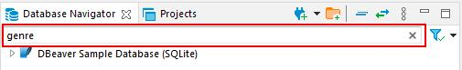

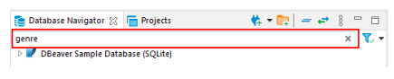

To filter objects by name, type the object name in the field. The tree dynamically updates to show connections/containers/tables/views with that name. To reset the filter, click the Clear icon () on the right end of the field.

You can select the types of filtering objects in the drop-down list on the right. And also use the filter only for active connections.

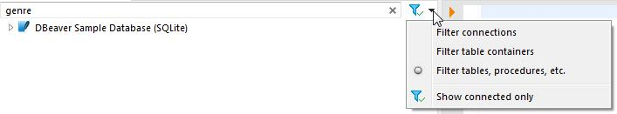

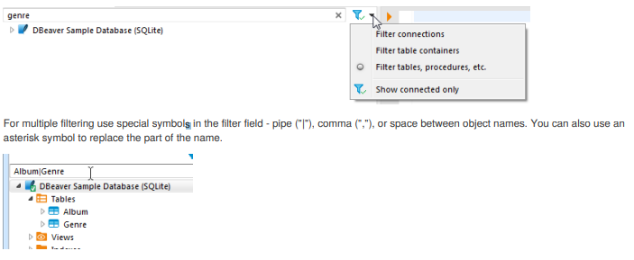

For multiple filtering use special symbols in the filter field - pipe ("|"), comma (","), or space between object names. You can also use an asterisk symbol to replace the part of the name.

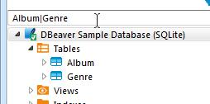

Another way to filter objects is to use the **Filter** item on the context menu of a single object. To filter objects using the **Filter** menu, right-click the object, then click **Filter** on the context menu, and then click one of the items on the submenu:

|  |  |  |
| --- | --- | --- |
| **Filter** | **Description** |  |
| **submenu item** |  |
|  |  |
|  |  |  |
| **Hide ‘[object** | Hides the current object while displaying the other ones |  |
| **name]’** |  |
|  |  |
|  |  |  |
| **Show only** | Shows the current object while hiding the other ones |  |
| **‘[object** |  |
| **name]’** |  |  |
|  |  |  |
| **Toggle filter** | Inverts the filtering – shows hidden objects and vice versa |  |
|  |  |  |
| **Clear filter** | Removes the filtering to display all objects |  |
|  |  |  |
| **Configure** | Appears only to the folder or parent nodes of database objects - like ‘Tables’, ‘Indexes’, etc. Allows the |  |
| **[objects] filter** | creation of a complex filter with multiple filtering criteria, see [Configure Filters](\l%20). |  |
|  |  |  |

The third way of filtering is to use the **Filter** item on the context menu on several objects:

1. Select several objects of the same type using Ctrl or Shift keys.

2. Right-click the selection, then click **Filter**, and then choose one of the options on the submenu:

|  |  |  |
| --- | --- | --- |
| **Filter submenu item** | **Description** |  |
|  |  |  |
| **Hide N objects** | Hides the selected objects while displaying the rest |  |
|  |  |
|  |  |  |
| **Show only selected objects** | Shows the selected objects while hiding the rest |  |
|  |  |  |

To reset such filters, right-click the parent (folder) node displaying the dots sign (...) , and then click **Filter -> Clear filter**.



**Configure Filters**

You can configure custom filters to filter database objects in the [Database Navigator](\l%20)and [Database Object Editor](\l%20).

To configure a custom filter:

1. In the Database Navigator, right-click the object and on the context menu click **Filter -> Configure [objects]**
2. **filter**. In the Database Object editor, in the toolbar of the **Properties** tab, click the Filter settings button (). The Filtering window opens.

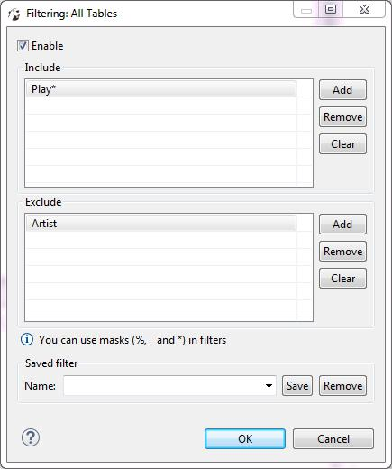

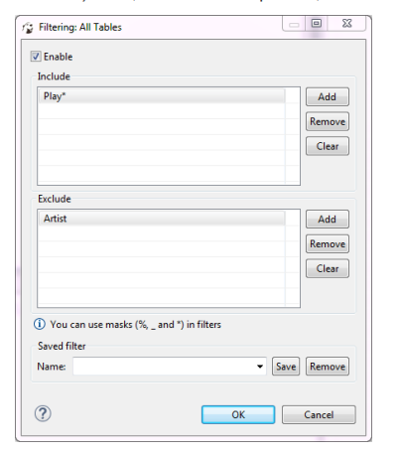

1. Select the **Enable** checkbox to activate the fields of the window.

3. If you want the filter to apply to all objects of a certain type, for example to all schemes, click **Show global filter**. Otherwise, the filter will apply only to the current object. NOTE: Once you apply the global filter, you cannot revert back to the local filer in the same window. To create a local filter, reopen the Filtering window, see Step 1.

4. For objects that you want to show, click **Add** next to the **Include** field and then, in the field itself, enter the name or combination of symbols to search. For objects that you want to hide, click **Add** next to the **Exclude** field and then, in the field itself, enter the name or combination of symbols to search. NOTE: You can use masks with % and * to replace one or more symbols and _ to replace one symbol in the search combination.

5. To remove one filtering combination, click the combination in the field and then click **Remove**. To remove all combinations from either of the fields, click **Clear** next to the field.

6. Once you set all filtering criteria, you can save a filter to use for other objects. To save the filter, in the Saved filter area, in the **Name** field, enter the filter`s name and click **Save**.

7. You can also remove any of the saved filters. To remove a filter, in the **Name** drop-down list, click the filter name and then click **Remove**.

8. Click **OK** to apply the filtering criteria. Otherwise, click **Cancel**.



**Projects View**

You might need to classify and group database connections into projects. Projects store objects related not to a particular database but to all database connections. These are usually files stored on the file system.

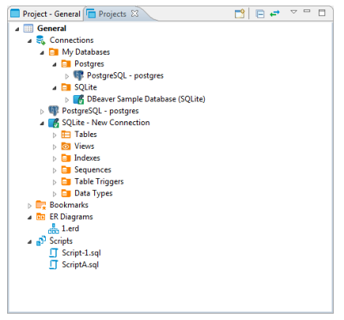

The Projects view displays all projects created in the system and provides tools to manage them. To open the Projects view, on the **Window** menu, click **Projects** (or useALT+W+Pshortcut).

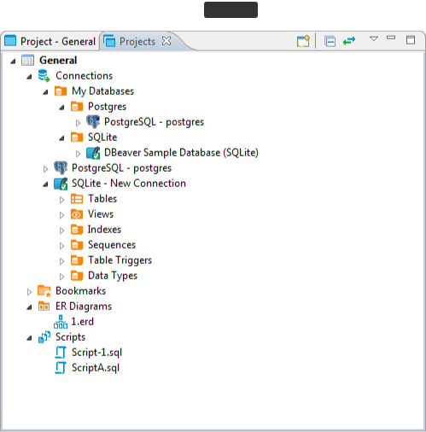

The projects are organized into a tree and all have the same high-level structure:

**Connections** – repeat the content of the Database Navigator view for this project. You can perform the same actions over theobjects of the databases as in the Database Navigator.



**Bookmarks** – contains bookmarks – shortcuts to database objects, see …



**ER Diagrams** - contains ER diagrams that you can drag-and-drop here from other folders



**Scripts** – contains scripts that you can drag-and-drop here from other folders



The Projects view provides a toolbar and View menu which contain generic items. Each object in the tree has its own context menu.

To open the view menu of the Projects view, click the View Menu button () in the upper-right corner of the window. The view menu contains the following items:

|  |  |  |  |
| --- | --- | --- | --- |
| **Icon** | **Item** | **Description** |  |
|  |  |  |  |
|  | Create Project | Opens the Create Project wizard |  |
|  |  |  |  |
|  | Refresh Projects | Refreshes the projects tree to display changes caused by creating modifying or deleting projects |  |
|  |  |  |  |
|  | Collapse All | Collapses the tree to the root level |  |
|  |  |  |
|  |  |  |  |
|  | Link with editor | - Enabled when at least one editor is open, otherwise disabled |  |
|  | - Highlights the object in the tree that has its editor open |  |
|  |  |  |
|  |  |  |  |



The toolbar is located in the title bar of the window, its buttons duplicate the view menu items except for the **Refresh Projects** one.

To open the context menu for an object in the tree, right-click the object. For information about context menu items of all objects under the **Connections** node of the tree, please see [Database Navigator](\l%20). The context menus of other nodes in the tree contain some basic items for copy-pasting, renaming, deleting objects, managing their properties, creating folders, etc.

The **Set Active Project** menu item (for a project root node) makes the project active, that is visible in the Database Navigator.



The **Link File (SQL Script)** and **Link Folder** menu items allow creating links to files and folders in the file system.

**Project Explorer**

The Project Explorer view displays detailed contents of the currently active project. To open the Project Explorer, click **Window ->Project Explorer**.

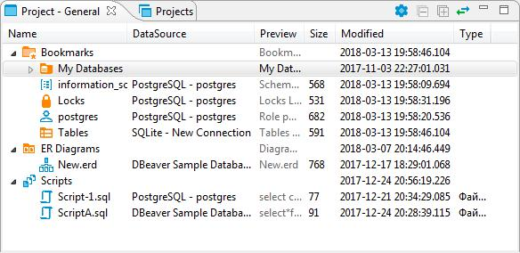

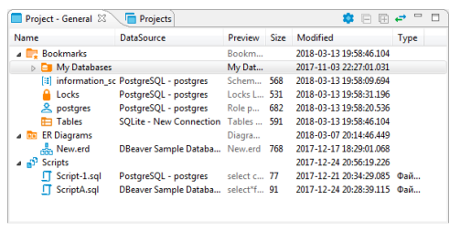

For information on how to change the view layout, please see the [Application Window Overview](\l%20)article.

The title of the Project Explorer includes the name of the project: Project – [Project name]. **General** is a project that initially exists in the system by default.

The Project Explorer displays the content of a project with metadata. The content includes: **Bookmarks**, **ER Diagrams**, and **Scripts**.

The metadata appears in columns which you can hide or show.

The Project Explorer view provides a toolbar that contains the following buttons:

|  |  |  |  |
| --- | --- | --- | --- |
| **Button** | **Name** | **Description** |  |
|  |  |  |  |
|  | **Configure columns visibility** | Opens a dialog box in which you can select columns to display in the view |  |
|  |  |  |  |
|  | **Collapse All** | Collapses the tree to the root level |  |
|  |  |  |  |
|  | **Expand All** | Expands the tree nodes |  |
|  |  |  |  |
|  | **Link with editor** | - Enabled when at least one editor is open, otherwise disabled |  |
|  | - Highlights the object in the tree that has its editor open |  |
|  |  |  |
|  |  |  |  |



To sort the metadata in the table by a certain column, click the column header.

**Query Manager**

Query Manager is a view that shows the history of all SQL queries that SQL and SQL and DBeaverhas executed during the current session.

NOTE: The SQL and SQL and DBeaverEE version persists all executed queries in the internal database so its execution history is available after the program restarts.

To open the Query Manager, do one of the following:

Click the arrow next to the **Transaction Log** button in the toolbar and then click **Query Manager** on the dropdown menu:

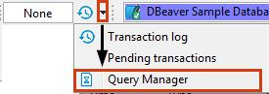

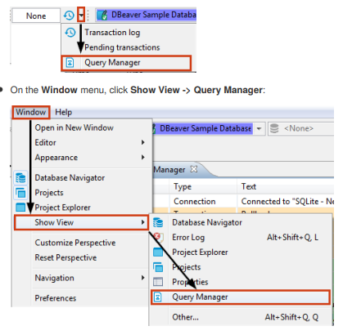

On the **Window** menu, click **Show View -> Query Manager**:

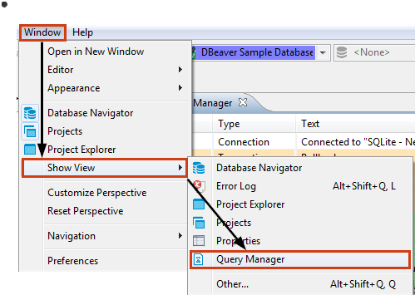

The Query Manager logs all queries together with their execution statistics (execution time, duration, number of fetched/updated rows, errors, etc.):

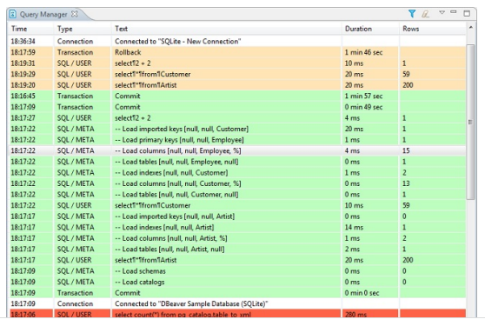

You can modify the look of the Query Manager by filtering queries and setting the number of entries displayed per page, as well as specifying some storage settings, see the ‘Query Manager Properties’ section below.

To erase all entries from the Query Manager, click the **Clear query manager log** button () in the view`s toolbar.

**Query Manager Properties**

To manage the look of the Query Manager, filter the entries, and modify the storage settings, click the **Set query manager filter** button () in the view`s toolbar. The Properties for Query Manager window opens:

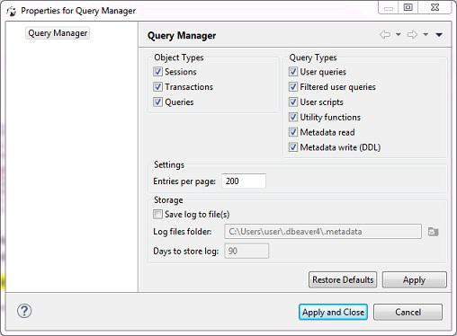

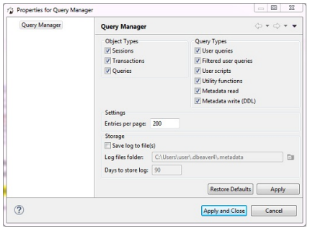

To filter entries by object type, select or clear the checkboxes in the **Object Types** section. To filter entries by query type, select clear the checkboxes in the **Query Types** section.



To change the number of entries displayed per page, enter the new number in the **Entries per page** field.



To set SQL and DBeaverto save the query log in a file, select the **Save log to file(s)** checkbox and then specify the file location in the **Logfiles folder** field.



After you make all necessary changes to the settings, click **Apply** to apply the changes and keep the window open or click **Apply andClose** to apply the changes and close the window. To discard all changes and return to the previous state, click **Restore Defaults**

**Database Object Editor**

The Database object, or metadata editor is available for multiple database objects such as tables, views and schemas. To open the metadata editor for an object, in the [Database Navigator](\l%20)or in the [Projects](\l%20)view:

Double-click the database object



Click the database object and press Enter or F4



The editor has three tabs:

**Properties** tab appears for all objects, contains properties of the database object and its sub-entities, see further in this article **Data** tab appears for tables and views and represents the[Data Editor](\l%20)



[**ER Diagram** tab appears for tables and schemas and displays ERD (Entity Relation Diagrams), seeER DiagramsandDatabaseStructure Diagrams](\l%20)



The tabs have the following common parts:

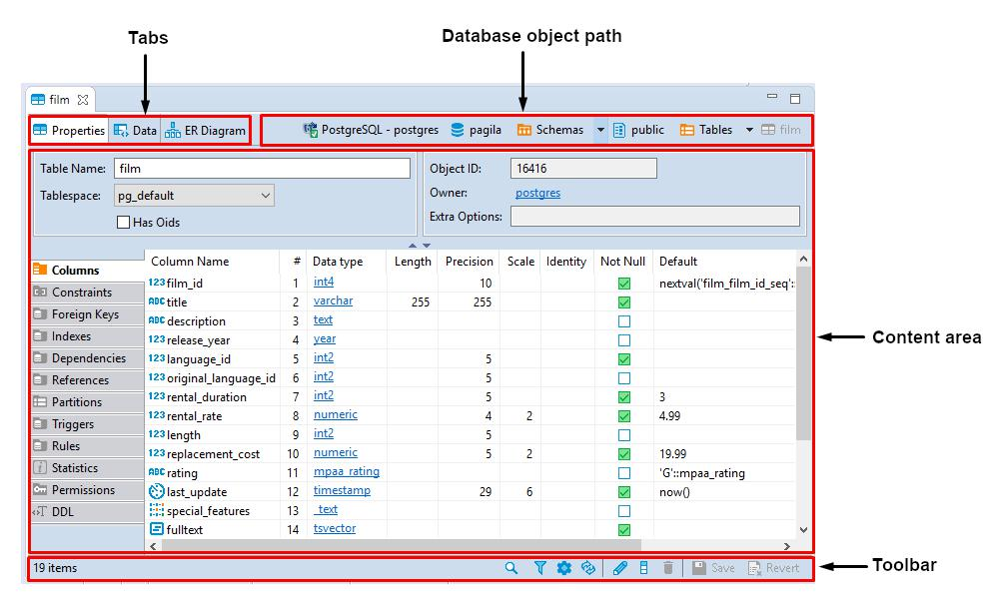

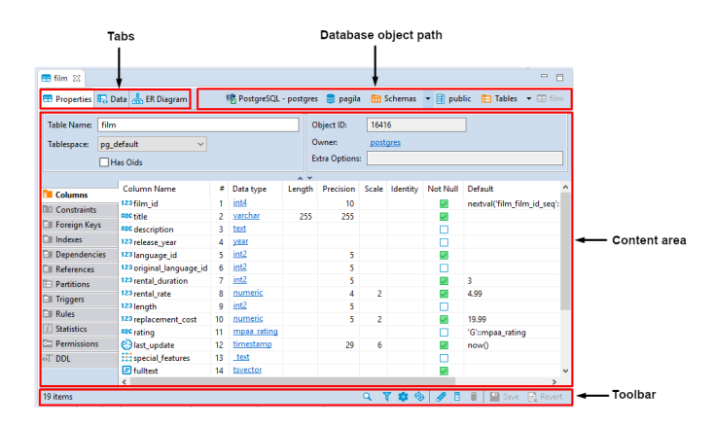

The object's path shows the chain of all its parent entities. The entities are clickable: clicking an entity in the path, depending on its nature, either shows its children or opens an editor or a settings window.

The toolbar contains different tools on each of the three tabs.

An asterisk appears in the title of an editor if it contains unsaved changes:

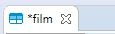

The Database Object editor supports the Ctrl+Z (undo) function.



**Properties Editor**

The Properties tab of the [Database Object Editor](\l%20)provides you with the tools to view and edit the database object's properties.

The content area of the Properties tab falls into two parts: the top pane displays properties of the current database object itself while the bottom pane contains properties of the object's sub-entities or some complex properties like DDL (an SQL description of the current database object).

Properties of the sub-entities appear in the side tabbed editors – to open such an editor, click the tabs on the left side of the area:

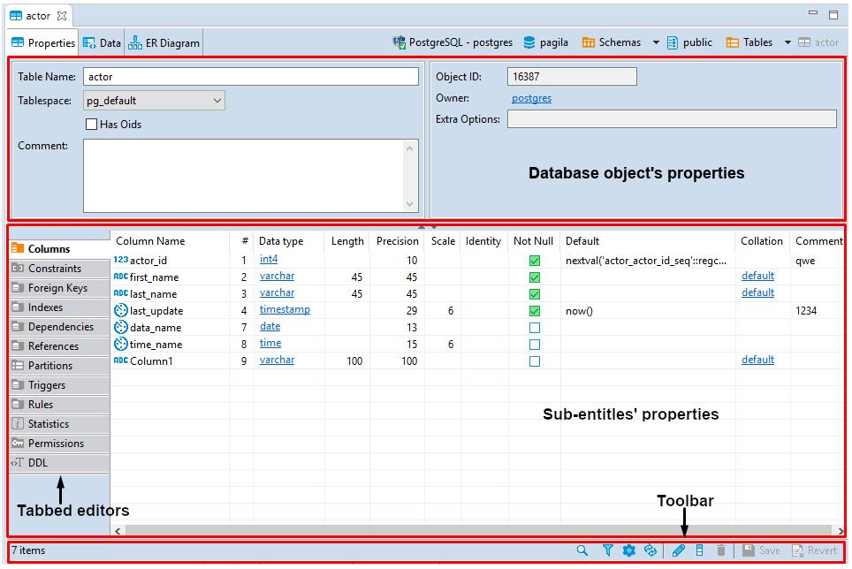

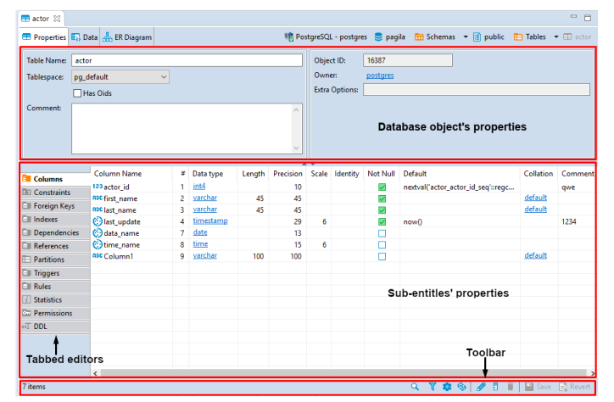

The toolbar at the bottom of the editor provides the following tools for the majority of sub-entities except for some specific ones like

Permissions (in PostreSQL) or SQL based views (DDL and Source):

|  |  |  |  |
| --- | --- | --- | --- |
| **Button** | **Name** | **Description** |  |
|  |  |  |  |
|  |  | Displays a search field next to the button: |  |
|  | Search items | - Type in the search combination - the content updates dynamically |  |
|  |  | - To remove the filter, click the cross icon next to the search field |  |
|  |  |  |  |
|  | Filter settings | Opens the Filtering window which allows setting a custom filter, see [Configure Filters](\l%20) |  |
|  |  |  |  |
|  | Configure | Opens the Configure columns dialog box in which you can select the columns to display or hide |  |
|  | columns | in the current view |  |
|  |  |  |  |
|  | Refresh the | Depending on the database type, refreshes either the current item or its parent or the whole |  |
|  | selected items | database object – reloading data from the database |  |
|  |  |  |  |
|  | View | Opens an editor/viewer for the item currently in focus |  |
|  |  |  |  |
|  | Create new | Creates a new item of the same type as currently displayed in the open view, for example, a |  |
|  | [items] | column |  |
|  |  |  |  |
|  | Delete database | Deletes the item currently in focus |  |
|  | object |  |
|  |  |  |
|  |  |  |  |
|  |  | - Same as the **Save** button on the application main toolbar |  |
|  | Save the current | - Same as Ctrl+S |  |
|  | - Opens the **Persist Changes** window that allows saving changes in the currently open sub- |  |
|  | contents |  |
|  | entity |  |
|  |  |  |
|  |  | NOTE: SQL and DBeaverrecommends saving work after each change. |  |
|  |  |  |  |



SQL and DBeaveruser guide 23/285

|  |  |  |  |
| --- | --- | --- | --- |
| **Button** | **Name** | **Description** |  |
|  |  |  |  |
|  | Revert to the last | Reverts all changes made to the whole database object to the last saved state |  |
|  | saved state |  |
|  |  |  |
|  |  |  |  |



Items in the tabbed editors have context menus which provide the same commands as those in the [Database Navigator](\l%20). To open a context menu for an item, right-click the item.

**SQL Script Editors**



SQL script editors (**DDL** and **Source**) of the Properties tab contain SQL script that you can either view or modify. The toolbar of the

DDL and Source tabs provides the following tools:

|  |  |  |  |
| --- | --- | --- | --- |
| **Button** | **Name** | **Description** |  |
|  |  |  |  |
|  | Load form file | - Allows selecting a file from the file system |  |
|  | - Disabled if the SQL code is read-only |  |
|  |  |  |
|  |  |  |  |
|  | Save to file | Allows saving the current SQL code to a file |  |
|  |  |  |  |
|  | Open in SQL console | Opens the SQL code in an SQL Editor |  |
|  |  |  |  |



You can select parts of the SQL code and apply generic commands such as copy-paste or SQL-specific commands like formatting – using the context menu. To open the context menu, right-click the SQL code. See [SQL Editor](\l%20)for information about SQL-specific commands.

NOTE: **SQL Assist**, **SQL Template**, and **SQL Context Information** menu items on the context menu are disabled if the SQL script is read-only.

**Data Editor**

The Data editor appears:

As the **Data** tab of the [Database Object Editor](\l%20), which is only available for tables and views.



As the **Results** tab when you run a custom SQL query in [SQL Editor](\l%20)



The Data editor allows the viewing and data editing of a database table or view. The central part of the Data editor is the data table.

The editor also provides two toolbars and a filter field:

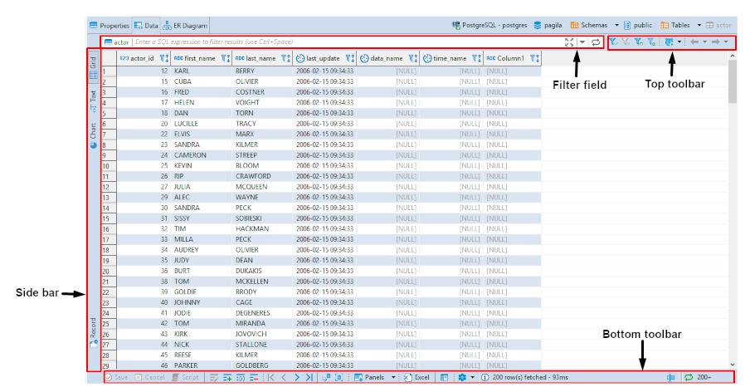

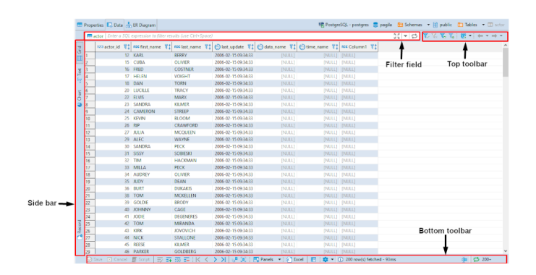

To learn how many rows the data table contains, click the **Calculate total row count** button in the bottom toolbar. The number of rows appears in a status field next to the button: 

To learn about ways to navigate data in the data table, see [Navigation](\l%20)article.

The top toolbar contains the following buttons:

|  |  |  |  |
| --- | --- | --- | --- |
| **Button** | **Name** | **Description** |  |
|  |  |  |  |
|  | **Apply filter** | Applies filter criteria entered in the filter field above the data table, see [Data Filters](\l%20)article for |  |
|  | **criteria** | more information |  |
|  |  |  |  |
|  | **Remove all** | Removes all filters and orderings applied to the data |  |
|  | **filters/orderings** |  |
|  |  |  |
|  |  |  |  |
|  | **Save filter** | Saves the current filter settings for the database object to apply next time when you reopen it in |  |
|  | **settings for** |  |
|  | the editor, see details in the [Data Filters](\l%20)article |  |
|  | **current object** |  |
|  |  |  |
|  |  |  |  |
|  | **Custom Filters** | Opens the Result Set Order/Filter Settings window, see Data Appearance article for more |  |
|  | information |  |
|  |  |  |
|  |  |  |  |
|  | **Configure auto-** | Allows configuring data auto-refresh settings, see [Data Refresh](\l%20)article for details |  |
|  | **refresh** |  |
|  |  |  |
|  |  |  |  |
|  | Forward and | Navigate forward and backward in the Data Editor history, see *History* section of [Navigation](\l%20) |  |
|  | backward - history | article for more information. The buttons are equivalent to pressing the key combinations: |  |
|  | navigation buttons | Alt+Left(backward) andAlt+right(forward). |  |
|  |  |  |  |



The side bar contains the following tabs:

|  |  |  |  |
| --- | --- | --- | --- |
| **Button** | **Name** | **Description Chart_button** |  |
|  |  |  |  |
|  | **Grid** | Switches to grid view of data |  |
|  |  |  |
|  |  |  |  |



**Data View and Format**

**Grid vs. Plain Text Views**



You can switch between two data presentations in SE version and four presentations in EE version. Pressing CTRL+~ switches available presentations in turn.



To see the data in a grid view, similar to an Excel spreadsheet, click the **Grid** button () on the bottom toolbar of the editor.



To switch to the plain text view, click **Text** () on the bottom toolbar.



To switch to JSON view (available in EE version only for MongoDB documents and JSON tables), click **JSON** on the toolbar.



To switch to XML view (available in EE version only for XML tables), click **XML** on the toolbar.



**Table vs. Record Views**



The table view is a standard table (Excel-like) in which columns are vertical and rows are horizontal. This view is the default one. If you

click the **Record** button in the bottom toolbar of the editor ( ), or press Tab , or right-click a cell and then click **Layout ->**



**Record** on the context menu, the rows and columns switch positions. The columns will appear as rows, and the rows will be hidden inone **Value** column which will show only one row of data. The column headers will shift from the top of the table to its left side:

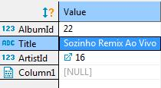

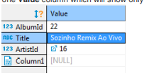

The Record view is useful if the table contains a big number of columns. To navigate from row to row of data, use the navigation buttons on the bottom toolbar of the editor: 

To return back to the standard table view, click the **Record** button again.

**Rows Coloring**



In the data editor, you can colour all rows that have the same value as a particular cell of a certain column. To do so, right-click the cell and click View/Format⇒Set the row colour for {column name = value} on the context menu:

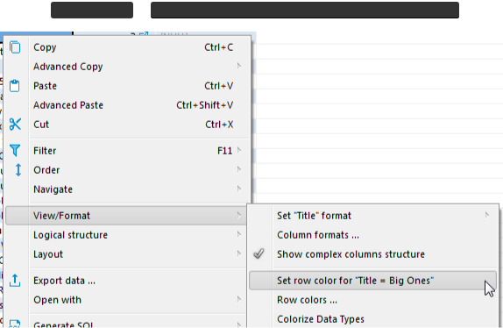

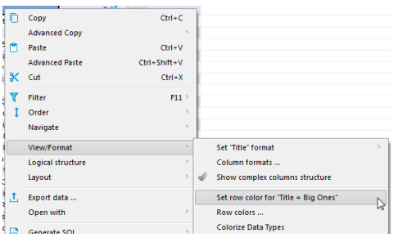

Then choose the colour in the palette window that appears and click **OK**. The current row and all other rows that contain the same value change their colour to the one you have selected:

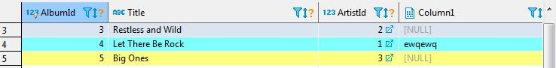

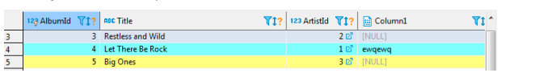

To remove the coloring by a particular column, right-click the cell again and click View/Format⇒Clear colour for {columnname = value} on the context menu.



SQL and DBeaveruser guide 30/285

By choosing View/Format⇒Row colors ... from the context menu, you can gain more precise control of coloring conditions:

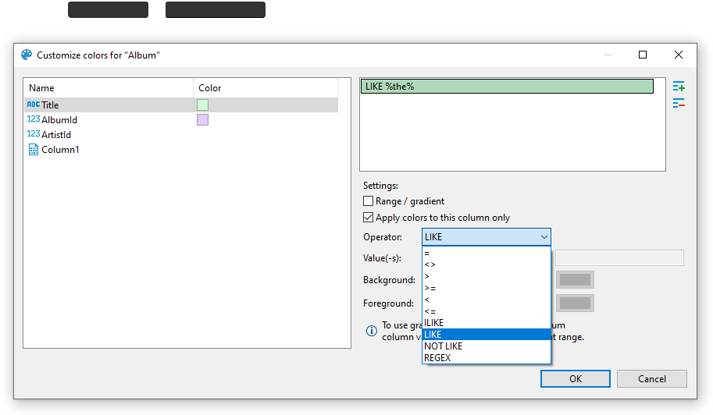

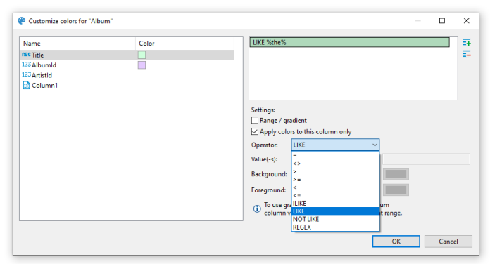

Here, you can define multiple conditions for single column using rich set of predefined operators, change background color and define a range between two values.

Operators work as you may expect. Note that they're executed on the client-side, that means no extra queries are made in order to apply colors.

**Value range / Gradient**

Value range allows you to paint your rows with gradient that fades from first value to second value:

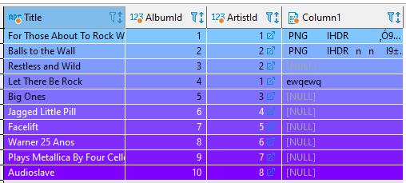

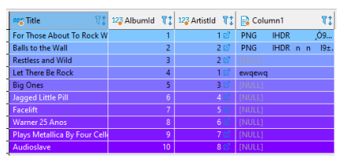

In this example we defined a range for column AlbumId that fades from #80c6ff to #8000ff between values 1 and 10 .



**Using regex**

You can use regular expressions for matching complex values. Otherwise, you can be artistic and, for example, paint rows with odd values in your favorite color:

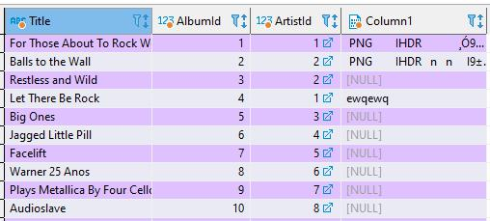

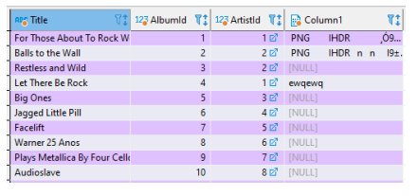



**Coloring by Data Types**



Besides colouring rows by a value, you can colour the values in the columns by data types. To do so, right-click any cell in the table and, on the context menu, click **View/Format ->Colourize Data Types**. The values in the cells will be coloured in different colours according to the current colour preferences:

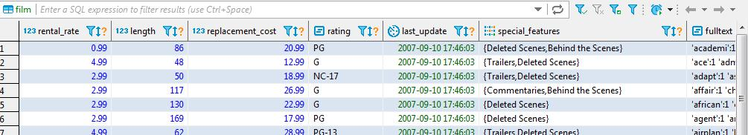

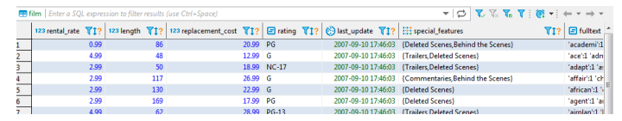

You can change the colour preferences in the Preferences window by: clicking **Window - > Preferences** on the main menu. In the window of the navigation pane on the left, expand **User Interface** and then **Appearance**, and then click **Colours and Fonts**:

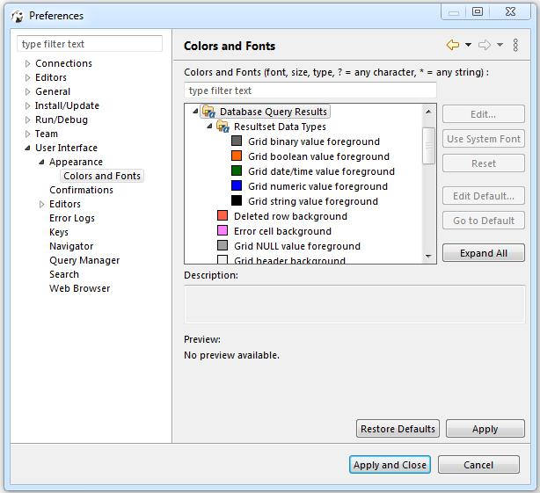

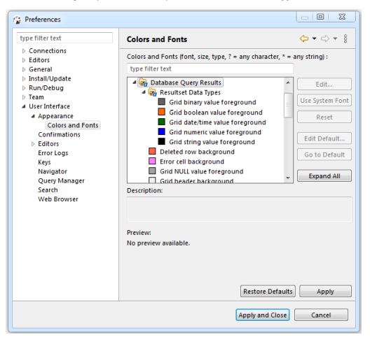

To remove the colouring by data types, on the context menu, click **View/Format ->Colourize Data Types** again.

**Transforming Data Presentation**



For string and numeric data types, SQL and DBeaverprovides tools to transform the data presentation into a number of formats, such as URL and Binary for strings and Epoch Time, Number Radix, etc. for numbers. To change the data presentation in a certain column, right-click a cell in the column. Then, on the context menu, click **View/Format -> Set {column name} format** and click the presentation type name:

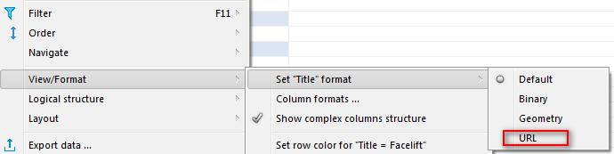

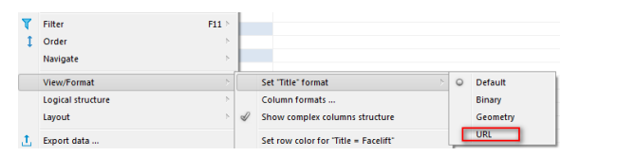

SQL and DBeaveruser guide

The Transformer settings window opens showing the value in the chosen format. Click **OK** to apply the change:

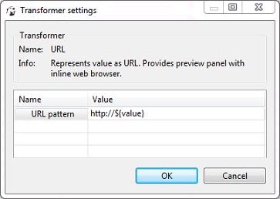

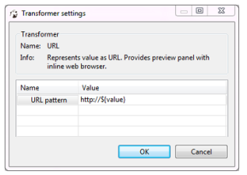

The values in the column appear in the new format.

NOTE: For URL format, the resulting cell provides a link to the URL in a browser window.

To roll back the changes to the default format, right-click any cell in the column, and on the context menu, click **View/Format -> Viewas -> Default**.

**Structurizing Complex Data Types**



For complex data types (that themselves represent a structure), such as objects, structures and arrays, SQL and DBeaverprovides a tool for breaking them into columns:

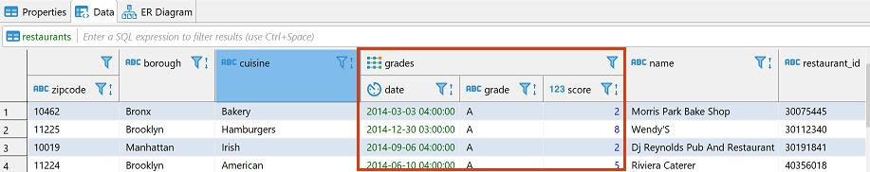

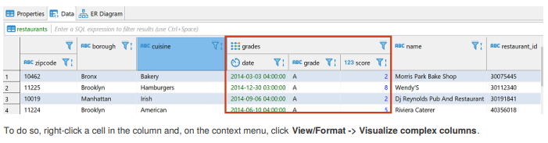

**Configuring Numeric and Time Data Formats**



You can specify the exact format of Time, Timestamp, Date, and Number data used in the currently open database or globally. To specify a format, right-click any cell in the table and, on the context menu, click **View/Format -> Data formats**. The Properties window opens displaying the **Data Formats** page:

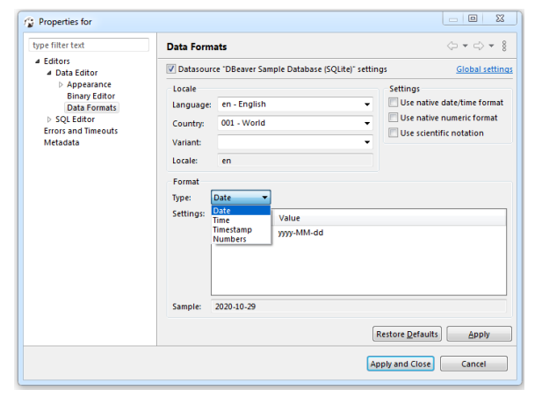

To configure only the format for the current database, select the **Datasource "[Connection name]" settings** checkbox. To configure the settings globally, to all databases that you have in SQL and SQL and DBeaver, click **Global settings**.

You can specify the locale for the data format in the **Locale** area. In the **Type** dropdown list, click the name of the data type and in the **Settings** table, click the required format.

To apply the changes and make them visible in the table, click **Apply and Close** and then refresh the window ( F5 ).



**Configuring Boolean presentation**

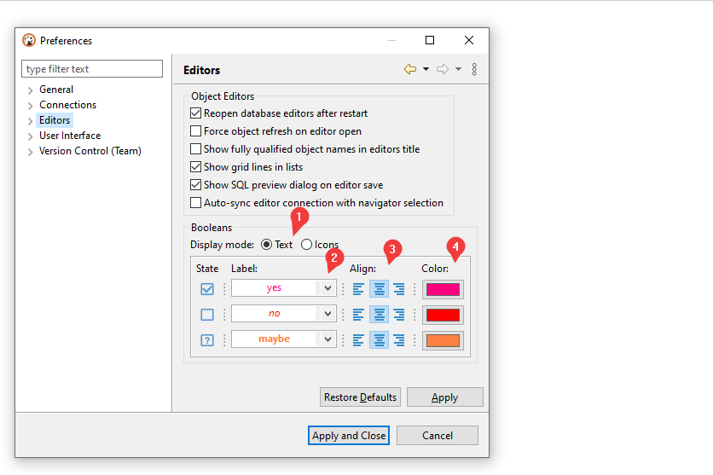

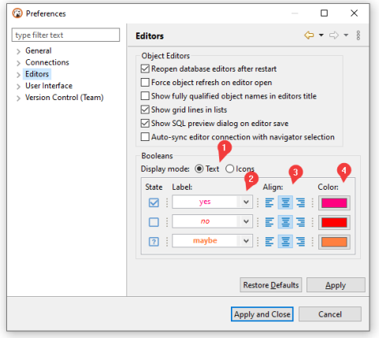

You can choose between two presentation modes 1:

Text-based



Icon-based



**Text-based presentation**

This is the most customizable mode. You can:

1. Change **labels** under Label column.

Otherwise, you can use presets available in Drop-down Menu2

2. Change **alignment** of value inside grid cell.3 Following variants are available: **left**, **center**, and **right**

3. Change **color** of value using color picker under Color column4.



You can reset color to match current theme's contrast color in Drop-down Menu2⇒Colors⇒Use theme default color



1. Change font **style** in Drop-down Menu2⇒Styles . Following variants are available: normal, **bold**, and *italic*



**Icon-based presentation**

This presentation only supports alignment changing.

**Data Filters**

You can apply custom filters to table contents or query results. There are several ways in which you can filter data in the table.

One of the ways is to use the filter field above the table next to the top toolbar. To filter data, enter an SQL expression into the field and click the Apply filter criteria button () next to the field or press Enter .

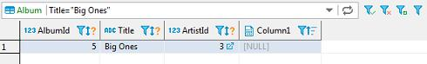

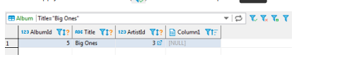

You can apply ready-to -use SQL expressions or SQL expression templates via the context menu. To select a ready SQL expression or a template, press F11 or right-click the cell, then click **Order/Filter** on the context menu and then click one of the expressions.

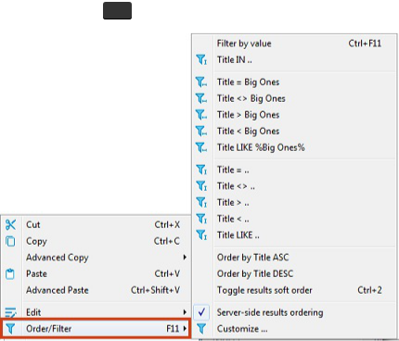

**Advanced filters configuration**

The main tool for managing the appearance of the data table is the Result Set Order/Filter Settings window.

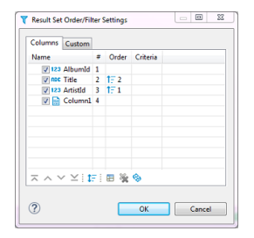

To open this window, click the Custom Filters button () in the top toolbar of the editor or click the Configure button () and then click **Order/Filter** on the dropdown menu.

The Result Set Order/Filter Settings window provides tools to:

Order data inside columns



Manage the display of columns in the table



Manage the order of columns in the table



Filter data in the table using an SQL expression



Another tool for managing the data appearance is the column headers. In the data table, every column header contains three elements which each has its own function: Data (column) type icon, column name, filter icon, and ordering icon.

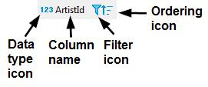

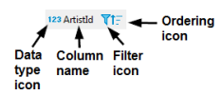

By simply clicking the column name or column type, the icon highlights the whole column.



You can click the column type icon and then drag and drop the column to a different position in the table.



You can click the column name and then drag the cursor to the right or left to highlight multiple columns.



Clicking the ordering icon allows you to order the data in the column in ascending or descending order - see the 'Ordering Data in Columns' section, further in this article



Clicking the filter icon allows you to filter the data by a cell value, see [TBA]



**Ordering Data in Columns**



You can order data in columns in one of the following ways:

1. Click the ordering icon () in the header of the column.

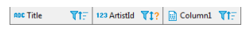

The icon has three states:

 Clicking once establishes ascending order ()



Clicking a second time changes the order to descending ( )



Clicking a third time removes the ordering from the column ()



To order data by several columns, go column by column, setting the order with the Ordering icon, starting from the column by which you want to order data first.

2. Click the Custom Filters button () in the top toolbar of the editor to open the Result Set Order/Filter Settings window (see

a) Next to the column by which you want to order data in the first turn, set the ascending or descending order using the same three-state principle as described above.

b) Set the ordering in other columns by which you want to sort the data in the second, third, etc. turn. The **Order** column indicates the order in which the sorting will happen.

NOTE: The number (**#**) column indicates the initial order of columns.

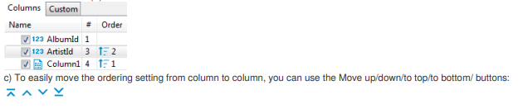

To reset the data ordering to its initial state, click the Reset button () in the same window.

Also, to remove all ordering settings, click the Remove All Filters/Orderings button ( ) in the top toolbar of the Data Editor.

**Managing Display of Columns in Data Table**



To hide a single column, right-click the column or any cell in it and click **View/Format -> Hide column** on the context menu. To unhide a hidden column, open the Result Set Order/Filter Settings window (see the image at the beginning of this article) and select the checkbox next to the column name, or click the Reset button ().

To display or hide columns in the data table, in the Result Set Order/Filter Settings window:

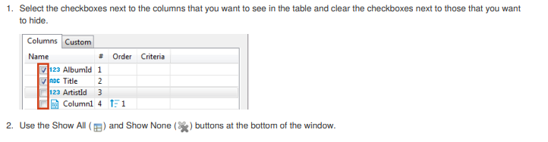

**Sorting Columns in Data Table**



You can modify the order of columns in the data table in two ways:

1. Click the icon in the column header and drag-and-drop the column to a new position.

2. To sort the column alphabetically, in the Result Set Order/Filter Settings window (open by clicking the Custom Filters button ( ) in the top toolbar of the editor), click the Sort button ()

3. In the Result Set Order/Filter Settings window, click the column to set the focus to it and then move it using the navigation buttons:

()

**Data Refresh**

Refreshing is necessary if the database contains changes made by other users working on it simultaneously with you, and you want to see them in your SQL and DBeaverwindow. To refresh data manually, right-click anywhere in the data table and click **Refresh** on the context menu or press F5 .



You can also schedule auto-refresh to happen on a regular basis. To auto-refresh the database on schedule:

1. Click the Configure auto-refresh button () on the top toolbar of the editor. The Auto-refresh configuration dialog box opens:

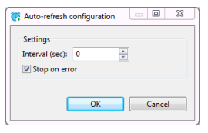

a) Set **Interval** in seconds.

b) Select the **Stop on error** checkbox if you want the refresh to stop when it encounters an error or clear it, if the refresh should ignore errors.

c) Click **OK**.

1. Alternatively, click the arrow next to the Configure auto-refresh button () to open the auto-refresh menu:

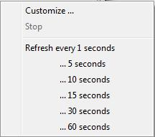

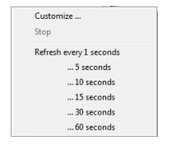

On the menu, you can click one of the preset options or click **Customize** to open the Auto-refresh configuration dialog box, see option 1.

When you perform either of these two alternative options above, the system starts refreshing the data as scheduled and the Configure auto-refresh button changes to **Stop auto-refresh** button ( ). To stop the auto-refresh, click the **Stop auto-refresh** button or click



the arrow next to it and click **Stop** on the auto-refresh menu.

**Data Viewing and Editing**

You can do inline editing (see the *Inline Editing* section below) as well as open the content of a cell in a separate editor (see the *CellEditor* section below).

When you make any changes to the data and save them using the steps described in this section, the changes will apply to the

database itself. Prior to saving the changes, you can preview the SQL script that the system sends to the database to apply the

changes there. To see the SQL script, after making changes and before saving or discarding them, click the **Script** button () in

the bottom toolbar. The Preview Changes window opens, in which you can only view the SQL script and copy it, if necessary:

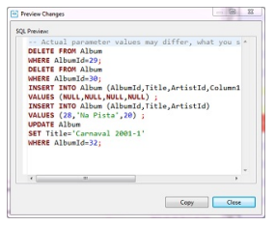

**Inline Editing**



Inline editing is when you modify the content right in the cell. To edit a cell inline, in the table do one of the following:

Double-click the cell.



Click the cell to set focus to it and press Enter .



Right-click the cell and click **Inline edit** on the context menu.



The cell is now editable and you can change its value.

To set the cell value to NULL, right-click the cell and click **Set to NULL** on the context menu.

To save the changes, click the **Save** button () in the bottom toolbar. To discard the changes, click the **Cancel** button ( ) in the bottom toolbar.

NOTE: Both the **Save** and **Cance**l buttons become editable only when you make changes in a cell and then jump to another cell.

**Cell Editor**



To edit data in a cell using a separate editor, do one of the following:

Right-click the cell and click **Edit cell** on the context menu.



Click the cell to set focus to it and press Shift+Enter or click the **Edit cell value in separate dialog/editor** button () in the bottom toolbar.



For cells of CLOB/BLOB data format, this action opens the contents of the cell in a new tab. For all other formats except CLOB/BLOB, this action opens a properties window for the cell:

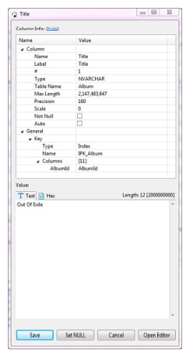

The window displays properties of the column in the value of the cell. Edit the value as required and click separate editor (tab), click **Open Editor**.

**Column Info** section and provides the **Value** section where you can modify the **Save**. To set the value to NULL, click **Set NULL**. To continue editing the cell in a

NOTE: SQL and DBeaverhas full support of CLOB/BLOB data types. You can view values, edit them, and save them back to the database. You can open CLOB/BLOB value in a separate editor (press Shift+Enter on a selected cell). You can save/load LOB value to/from



regular files. SQL and DBeavercan recognize that some BLOB column keeps images (gif, png, jpeg, bmp). In this case SQL and DBeavershows LOB contents as an image. It is convenient to open the value view panel (press F7 ) and browse images.



**Adding, Copying and Deleting Rows**



You can add an empty row below the row in focus. To add an empty row, click the **Add new row** button ( ) on the bottom toolbar.

Use inline editing or open the cell values in a separate editor to populate them with data (see the sections above).

You can copy any row or several rows currently in focus. To copy rows, highlight one or more rows and click the **Duplicate current row** button () in the bottom toolbar. The duplicate rows appear below the rows in focus.

To delete a row or rows, set the focus to the rows and click the **Delete current row** button () in the bottom toolbar. The rows are coloured red, which means that they are marked for deletion and will be deleted when you save the changes.

To save any such changes, click the **Save** button () on the bottom toolbar. To discard the changes, click the **Cancel** button ( ) on the bottom toolbar.

**Copying/Pasting Cells**



To copy the content of one or several cells to the clipboard in the TAB-delimited format, press Ctrl+C or right-click the cell or cell selection and click **Copy** on the context menu. Then you can paste the copied selection into a spreadsheet editor (similar to Excel).



SQL and DBeaverprovides the advanced copy option that allows configuring additional copy settings (copy with column names/row numbers, configure delimiter and choose value format). To copy cells with additional settings, press Ctrl+Shift+C or right click the cell(s) and



click **Advanced Copy** on the context menu.

Pressing Ctrl+V on a cell pastes the copied content into the cell applying appropriate data type conversion. The **Advanced Paste** option on the context menu or pressing Ctrl+Shift+V pastes several cells.



SQL and DBeaveruser guide 41/285

**Defining Virtual Keys**



To be able to save column value changes, a table must have some unique key (primary key or unique index). Some databases (Oracle, DB2, PostgreSQL) support a special virtual unique column that SQL and DBeavercan use to save changes. In other cases, you can define a virtual key – a set of columns that forms a unique combination of values. When you try to save changes in a table without a unique key, SQL and DBeaverdisplays the following error message:

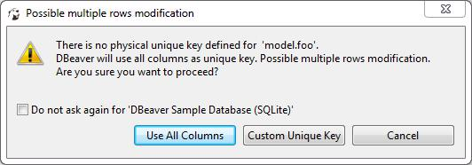

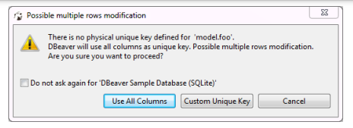

To use all columns as the virtual key, click **Use All Columns**. To create a custom key, click **Custom Unique Key**. Alternatively, to create a unique custom key, you can click the **Configure**( ) button on the bottom toolbar and then click **Define virtual unique key**



on the Configure menu. The Define virtual unique identifier window opens:

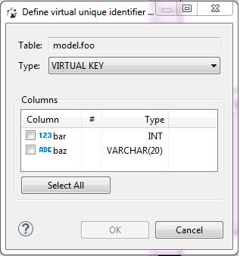

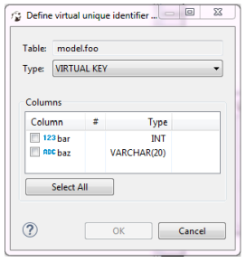

To define the key, select some of the columns or click **Select All** and then click **OK**. To remove a unique key from a table, click the **Configure** button in the bottom toolbar and then click **Clear virtual unique key**.

**Assignment**

Feedback:

First of all, I am Dubbaka Srikanth, I am very much thankful to Prof. Ch. Radhakumari madam for thewonderfulopportunityshegavetoupgrademyskills.SURETrustis doingagreat service by providing free courses to students. During the course we notonlylearnedtheskillsbutalsodiscipline,dedicationandattentivenessaswell.

SURE Trust is also conducting LST Sessions on Sundays whichis more usefulforusinour daytodaylife.

OurTrainerMr.R. Uma Maheshisoneofthebestwegotasheteachesthecourse in a very understandable manner. Mr. R. Uma Maheshis always ontime for the session and he never skipped any classes. Mr. R. Uma Maheshprobes us with questions during the session and clears our doubts when weareunabletounderstandonthetopic.Mr.R. Uma Maheshgaveus

assignmentsoneverytopicandhelps ustofinishitifwearestuckorunabletocompleteit.ThankyousomuchMr.R. Uma Mahesh

Heartly wishing SURE TRUST & Mr. R. Uma Maheshfor their futureendeavors

* 1. Uniquenessofthe Course:
* Coursesarethought practicallyandexplainedindetail.

*Machine Learning is the goal of our course and it was thought in an easyunderstandablemanner.

* Assignmentsaregivenon everytopicwhichmade ustolearn.
* Concentrated on every student and thought us discipline along with thecourse.
* Madeustoprepare thestudent’sreportwhich willbehelpfulforour futurereference.
  1. ConcludingRemarks:

I am very much happy that I have learnt the course successfully. I am blessedto learn the course in SURE TRUST. I would like to thank each and every personof SURE TRUST for providing me an opportunity to learn the course. SURETRUST is helping the students to gain the knowledge on latest technology andhelpsthemtogetgoodjobs.IamproudtobeastudentofSURETRUST.